# **Phase 1: Problem Understanding & Industry Analysis**

## **Requirement Gathering**

The Urban Issue Management System is designed to streamline and automate the process of reporting, tracking, and resolving urban infrastructure issues (such as potholes, streetlight outages, garbage problems, playground maintenance, and traffic signal malfunctions). The primary goal is to provide a responsive, transparent, and efficient mechanism for citizens to report problems, for staff to manage and resolve them, and for supervisors and city management to monitor performance and trends.

Key requirements identified include:

* Citizens need a simple and accessible way to submit urban issues, specifying details such as location, type, and description.
* Each issue must be routed to the appropriate department for resolution based on type and location.
* Staff and supervisors require a centralized platform to track the progress of each reported issue.
* Automated assignment of priority and escalation for urgent or critical issues is essential.
* Timely notifications and communications (e.g., email alerts) are required for both citizens and staff.
* The system must support reporting and analytics for operational oversight and continuous improvement.

## **Stakeholder Analysis**

The main stakeholders for this project are:

* Citizens: Individuals who identify and report urban issues within the city limits. Their experience should be straightforward and transparent, with notification at each major status change.
* City Staff: Employees responsible for investigating and resolving reported issues. This includes field workers, department representatives, and supervisors.
* Supervisors/Managers: Oversee department performance, approve certain issues (especially urgent or costly ones), and manage escalations.
* City Management: Responsible for oversight, policy, and resource allocation, requiring dashboards and analytics.
* IT/Admin Team: Maintains the system, adapts processes, and manages integrations with other city systems.

Understanding the needs and workflows of each group is essential to the solution’s success.

## **Business Process Mapping**

The current (as-is) process is typically manual or semi-automated, involving phone calls, paper forms, or siloed apps. Issues can be lost, delayed, or tracked inefficiently. The proposed (to-be) process, enabled by Salesforce, is as follows:

1. Citizen submits a new urban issue via a portal or mobile app.
2. The system captures details, assigns a unique issue number, and automatically routes it to the relevant department based on the type and location.
3. Priority is automatically set according to predefined rules (e.g., urgent for main roads or hazardous locations).
4. Staff receive notification and a task for follow-up.
5. Supervisors are notified for approval if the issue is urgent or high-cost.
6. Issue status updates are communicated back to the citizen.
7. The system provides real-time dashboards and reports for management oversight.

This streamlined process reduces delays, increases accountability, and enhances citizen satisfaction.

## **Industry-Specific Use Case Analysis**

Municipalities worldwide face similar challenges in managing urban infrastructure issues. Common pain points include lack of transparency, slow response times, poor communication with citizens, and difficulty in tracking performance. Industry best practices increasingly focus on digital transformation, citizen engagement, mobile accessibility, and data-driven insights.

Our solution draws inspiration from leading smart-city initiatives, leveraging Salesforce’s platform capabilities for automation, notification, and analytics. The system is designed to be scalable, adaptable for future needs (such as IoT sensor integration or AI-driven prioritization), and compliant with municipal data policies.

## **AppExchange Exploration**

To accelerate delivery and maximize value, the project explored relevant Salesforce AppExchange solutions for:

* Citizen service request management
* Field service scheduling and optimization
* GIS and mapping integrations
* Prebuilt dashboards and analytics for city operations

While several apps offer useful features, most are either too generic or lack the specific process customizations required for our city's needs. As a result, a custom Salesforce implementation, with selective use of AppExchange components for notifications or mapping, is chosen as the optimal path.

# **PHASE 2 – Org Setup & Configuration (Urban Issue Management System**

## **Company Profile Setup**

The foundational org settings were configured under Setup → Company Information → Edit for the Urban Issue Management System.

* Name: Urban Issue Management System
* Time Zone: GMT+05:30 Asia/Kolkata
* Locale: English (India)
* Language: English, Currency: INR

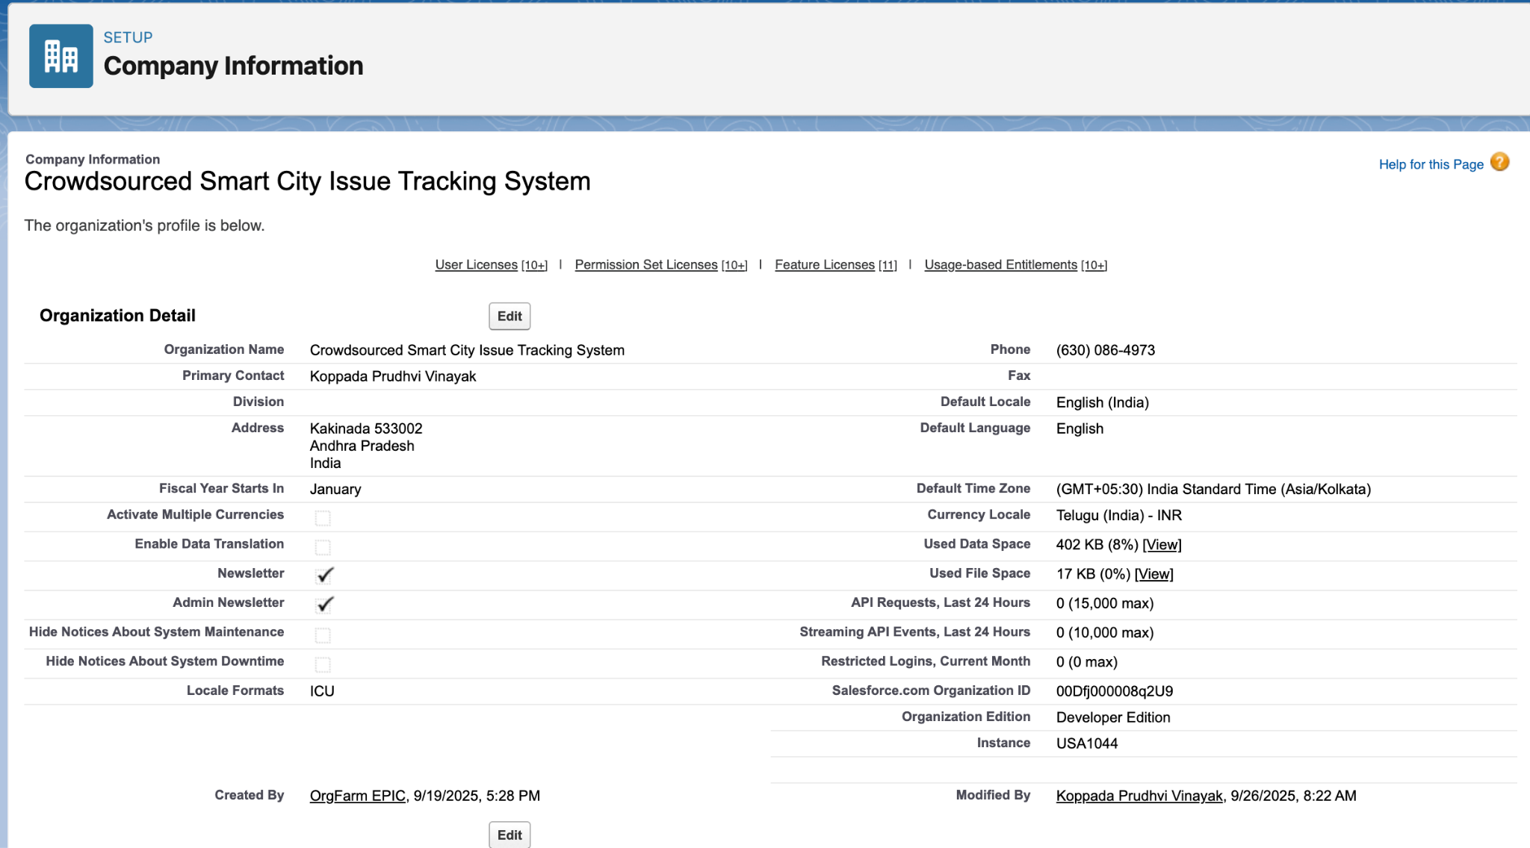

## **Business Hours & Holidays**

Standard business hours were configured to match city/municipal operating hours for case routing and SLA calculations.

* Path: Setup → Business Hours → New
* Name: Urban Issue Standard Hours
* Time Zone: GMT+05:30 Asia/Kolkata
* Working Hours: Monday–Friday, 9:00 AM–6:00 PM
* Holidays: City government holidays and national holidays added for accurate service calculations.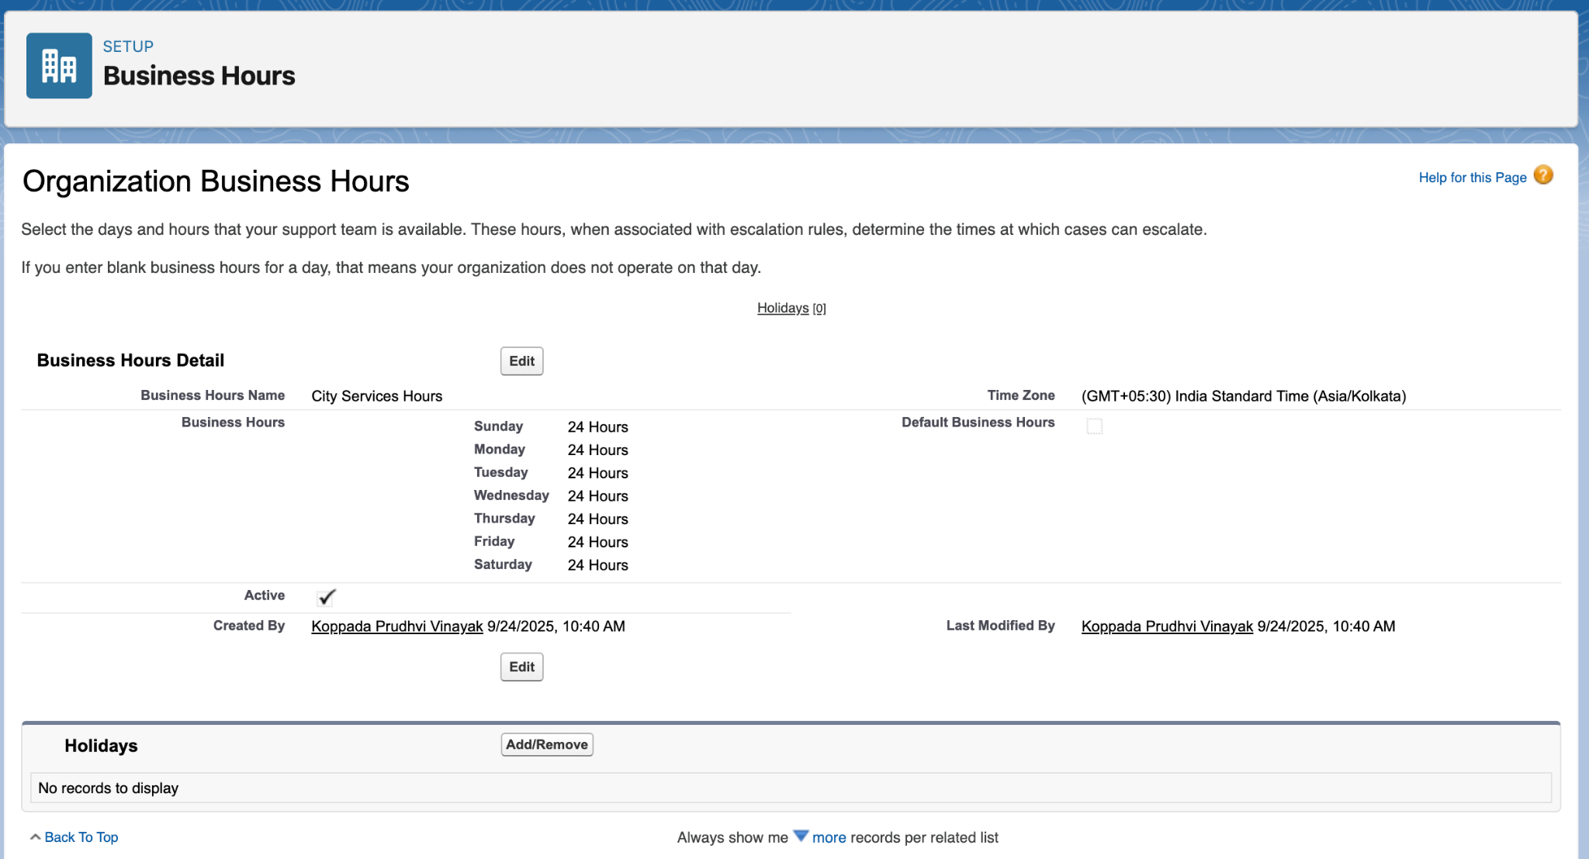

## **Fiscal Year Setup**

The fiscal year was set to standard to align with municipal reporting cycles.

* Path: Setup → Fiscal Year
* Type: Standard Fiscal Year
* Start Month: January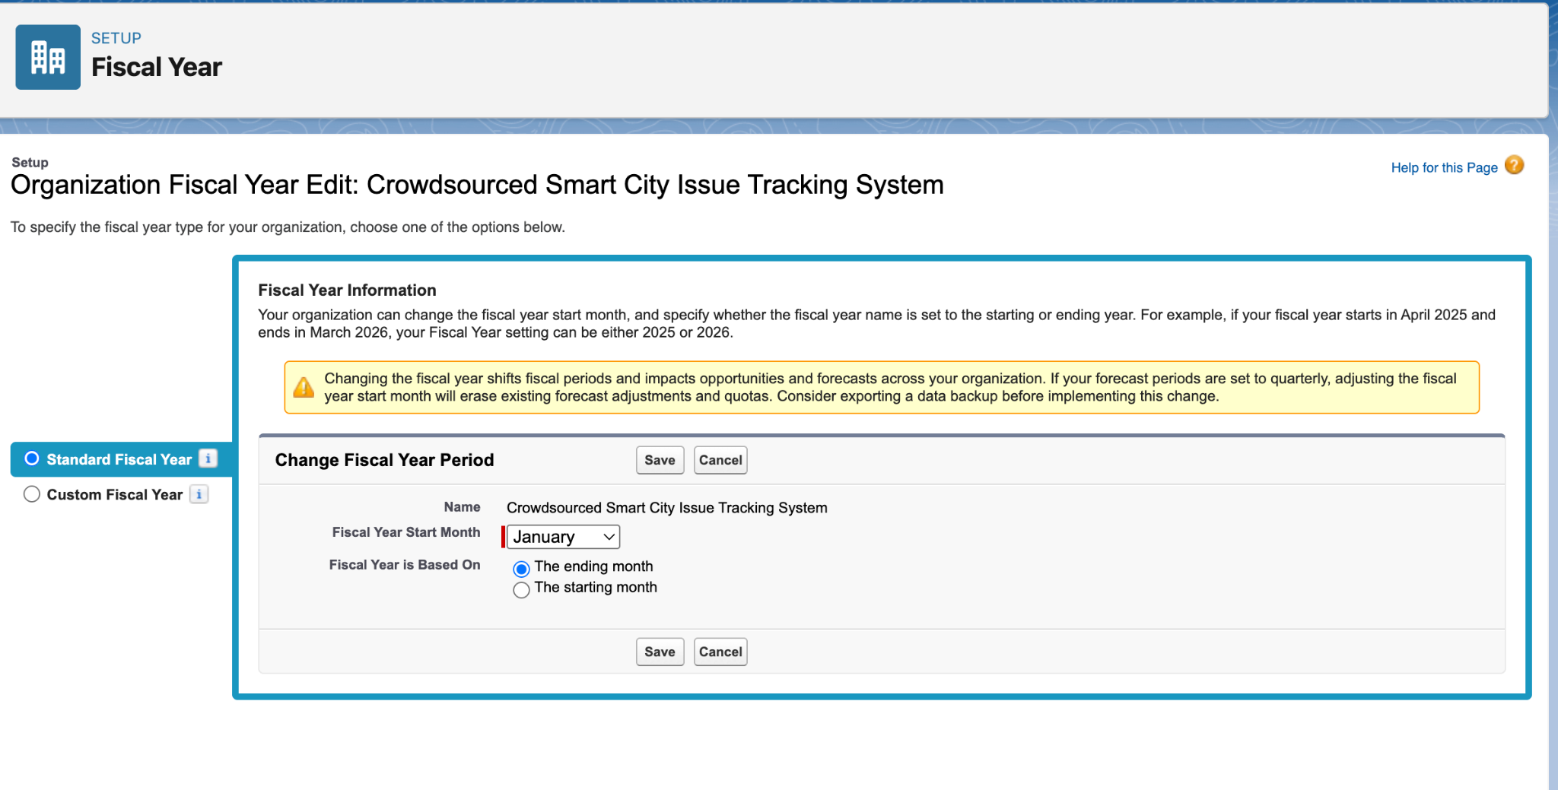

## **User Setup (Profiles, Roles, Permission Sets, Users)**

### **Profiles**

* Setup → Users → Profiles.
* Cloned "Standard User" profile as Department Staff.
* Cloned again as Department Head.
* (Optional) Created "Citizen" profile for future Experience Cloud/portal use.
* Assigned these profiles to the corresponding users.

**

### **Roles**

* Setup → Users → Roles.
* Created the following hierarchy:
  + City Admin (top, reports to CEO)
  + Department Head (reports to City Admin)
  + Department Staff (reports to Department Head)
* Assigned these roles to the users created earlier.

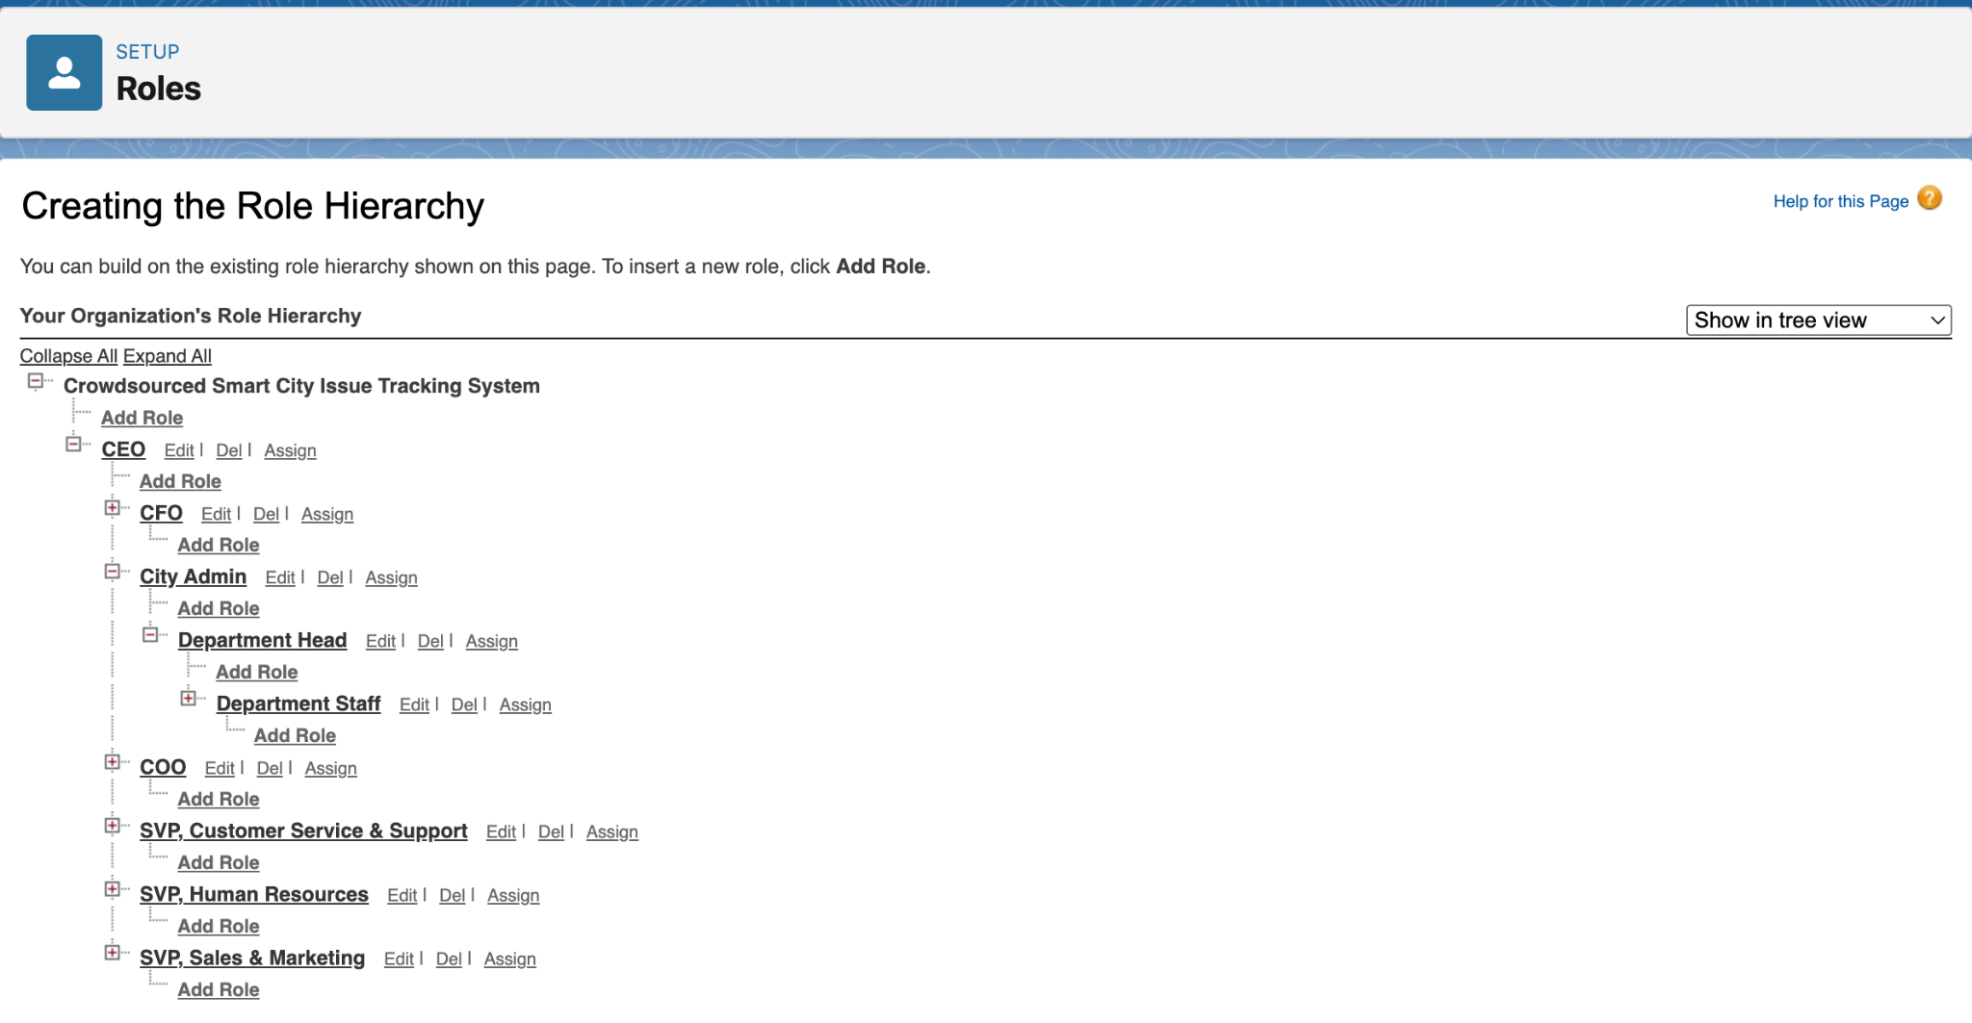

### **Permission Sets**

* Setup → Users → Permission Sets.
* Created Department Extended Access permission set.
  + Checked "Export Reports" and "Run Reports" under System Permissions.
* Assigned this permission set to department users (e.g., Ravi Kumar, Sita Sharma).

### **User Setup & Licenses**

* Setup → Users → Users.
* Created users for:
  + System Administrator (yourself)
  + Department Heads (e.g., Ravi Kumar)
  + Department Staff (e.g., Sita Sharma)
* Assigned “Standard User” or custom profile (created in next step).
* Set role to be assigned after roles were created.

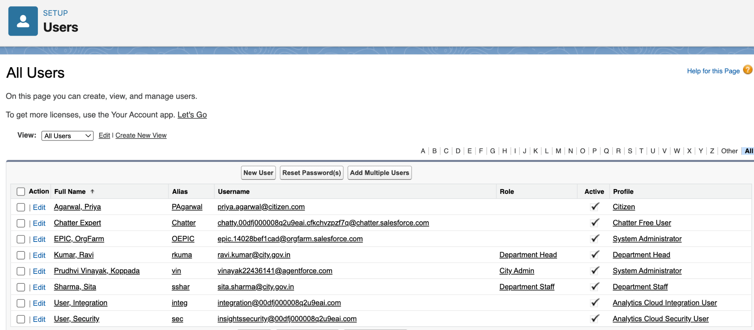

## **Org-Wide Defaults (OWD)**

## Setup → Security → Sharing Settings.

## Set Org-Wide Defaults (Default Internal Access) for:

## Department: Public Read Only

## Urban Issue: Private

## Citizen: Private

## Feedback: Private

## Saved the changes.

## Note: Default External Access left unchanged (no community/portal users yet).

## **Login Access Policies**

## Setup → Security → Login Access Policies.

## Enabled “Administrators Can Log in as Any User”.

## **Dev Org Setup**

* All steps performed in a Salesforce Developer Edition org.

## **Sandbox Usage**

## Developer Edition org used; no sandboxes available.

## Noted in docs that for production, sandboxes and change sets/SFDX would be used for testing/deployment.

# **PHASE 3 – Data Modeling & Relationships (Urban Infrastructure Issue Reporting)**

## **Standard & Custom Objects**

The data model leverages both standard and custom objects to create a scalable, government-centric application.

Standard Objects:

* User: Represents city staff, department heads, and system administrators who manage issues and oversee departments.

Custom Objects:  
Four custom objects form the backbone of the solution:

* Department: Represents each city or municipal department responsible for handling reported issues (e.g., Sanitation, Public Works, Utilities).

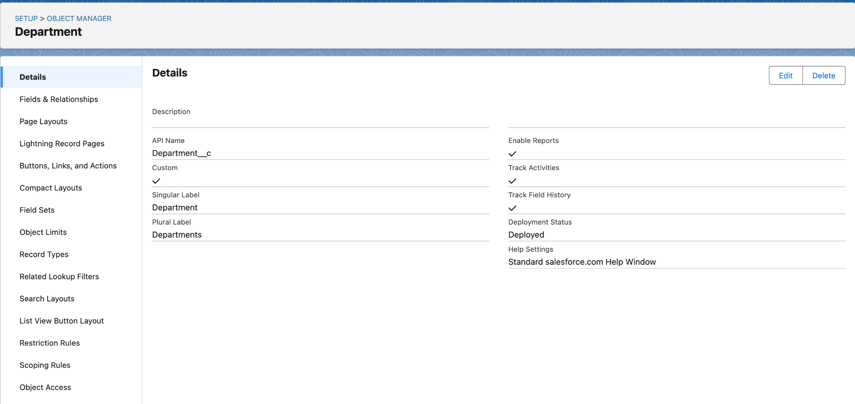

* Urban_Issue: Captures all reported urban issues, including details like status, type, location, and assigned department.

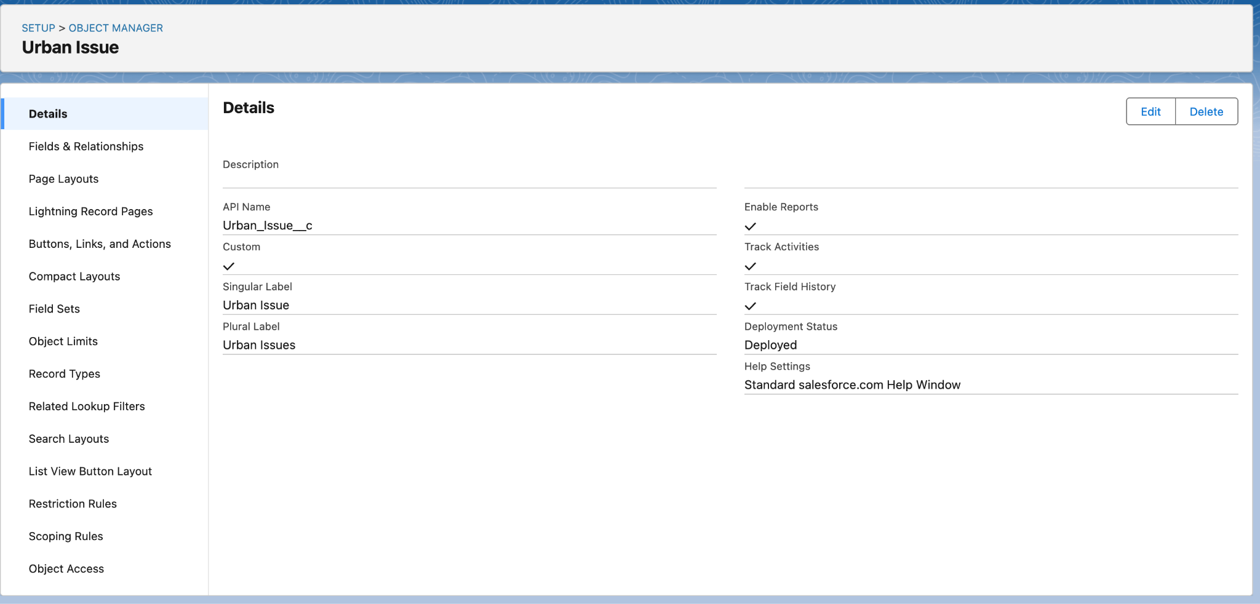

* Citizen: Stores information about citizens who report issues (name, contact details, government ID, etc.).

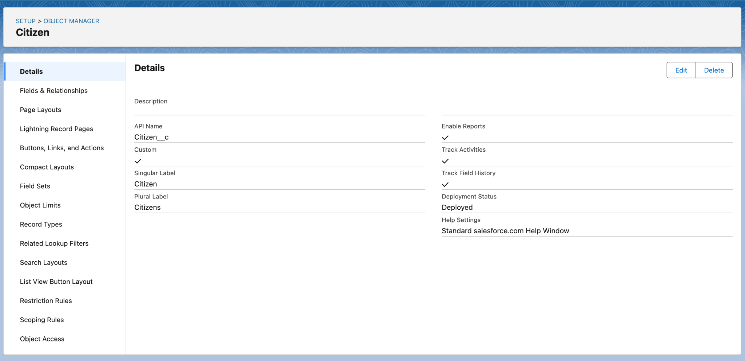

* Feedback: Collects feedback and ratings from citizens about the quality and timeliness of issue resolution.

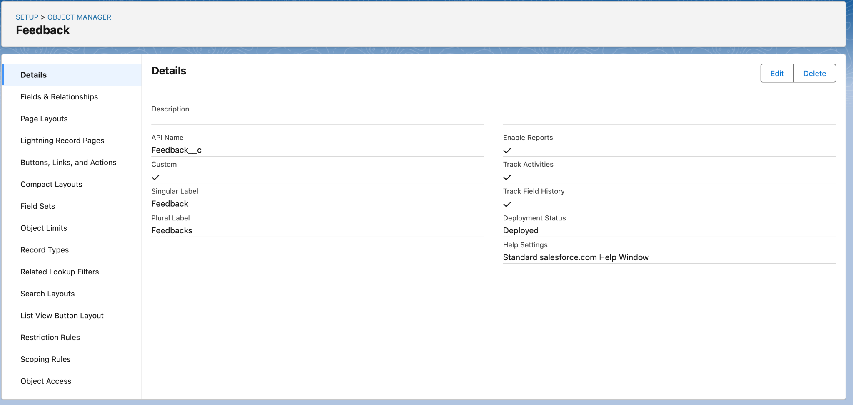

* Staff: Helps to Track the staff information.

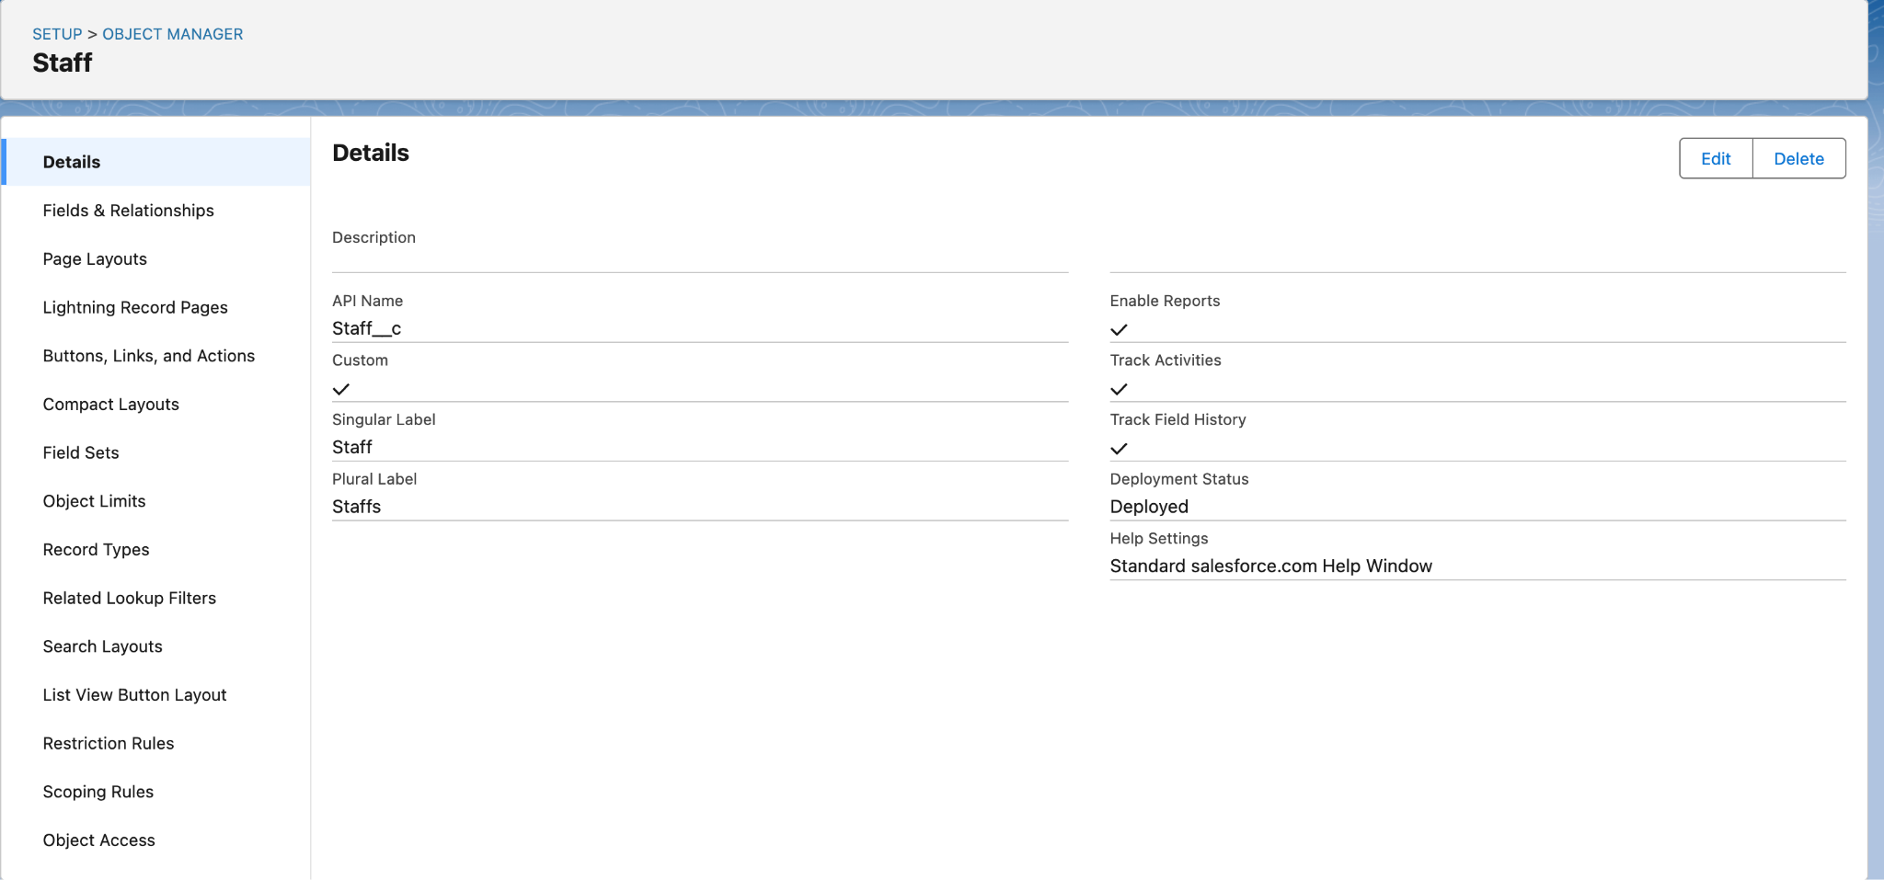

## **Fields & Relationships**

Custom fields capture essential data, and lookup relationships create the necessary links between objects.

Relationships:

* Urban_Issue → Department: Lookup relationship; each urban issue is assigned to a department based on type/location.
* Urban_Issue → Citizen: (Future/optional) Lookup relationship, if issues are to be directly linked to the reporting citizen (not yet implemented).
* Feedback → Citizen: Lookup relationship; feedback is tied to the citizen who submitted it.
* Feedback → Urban_Issue: Lookup relationship; feedback is tied to the resolved urban issue.
* Department → Department Head: Lookup to User; identifies the supervisor/manager for each department.

Custom Fields:

*On Department:*

* Department_Code (Text)
* Department_Email (Email)
* Department_Head (Lookup to User)
* Phone_Number (Phone)

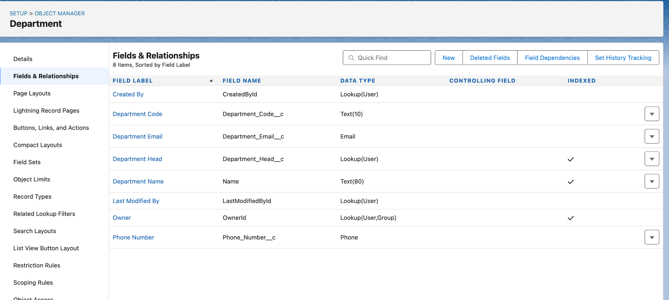

*On Urban_Issue:*

* Issue_Title (Text)
* Description (Long Text Area)
* Location (Text)
* Status (Picklist: New, In Progress, Resolved, Closed)
* Department (Lookup to Department)
* Department_Name (Text, for sharing rule workaround)

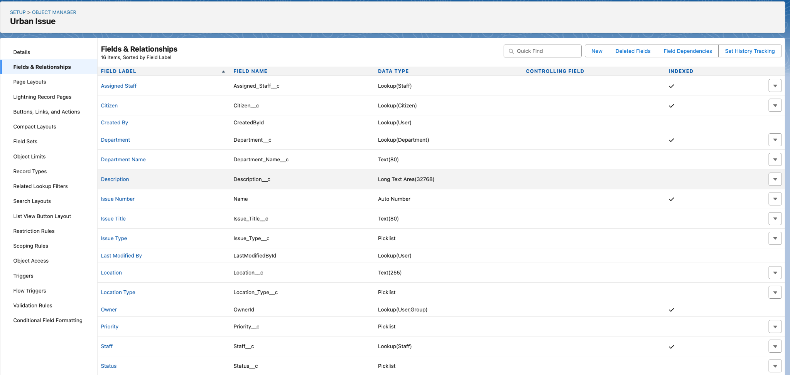

*On Citizen:*

* Email (Email)
* Phone_Number (Phone)
* Address (Text Area)
* Government_ID (Text)

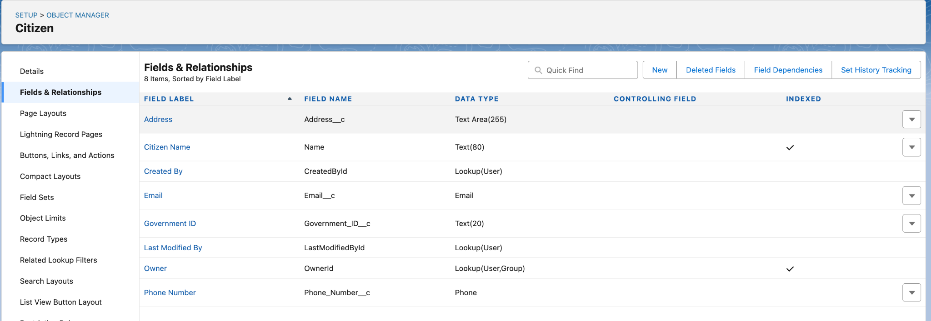

*On Feedback:*

* Feedback_Text (Long Text Area)
* Rating (Picklist: 1, 2, 3, 4, 5)
* Citizen (Lookup to Citizen)
* Urban_Issue (Lookup to Urban_Issue)

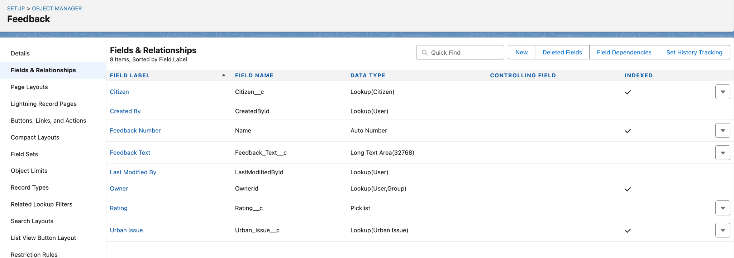

## **User Interface & Layouts**

To ensure a user-friendly and efficient on-screen experience:

Page Layouts:  
A dedicated page layout was created and customized for each custom object (Department, Urban Issue, Citizen, Feedback), organizing fields for easy data entry and review.

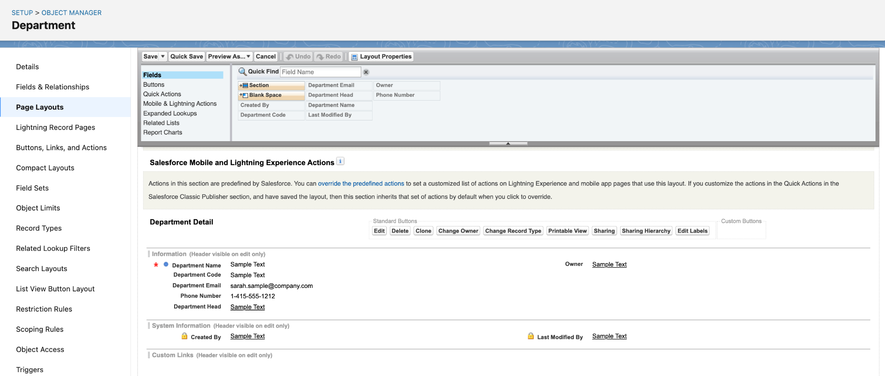

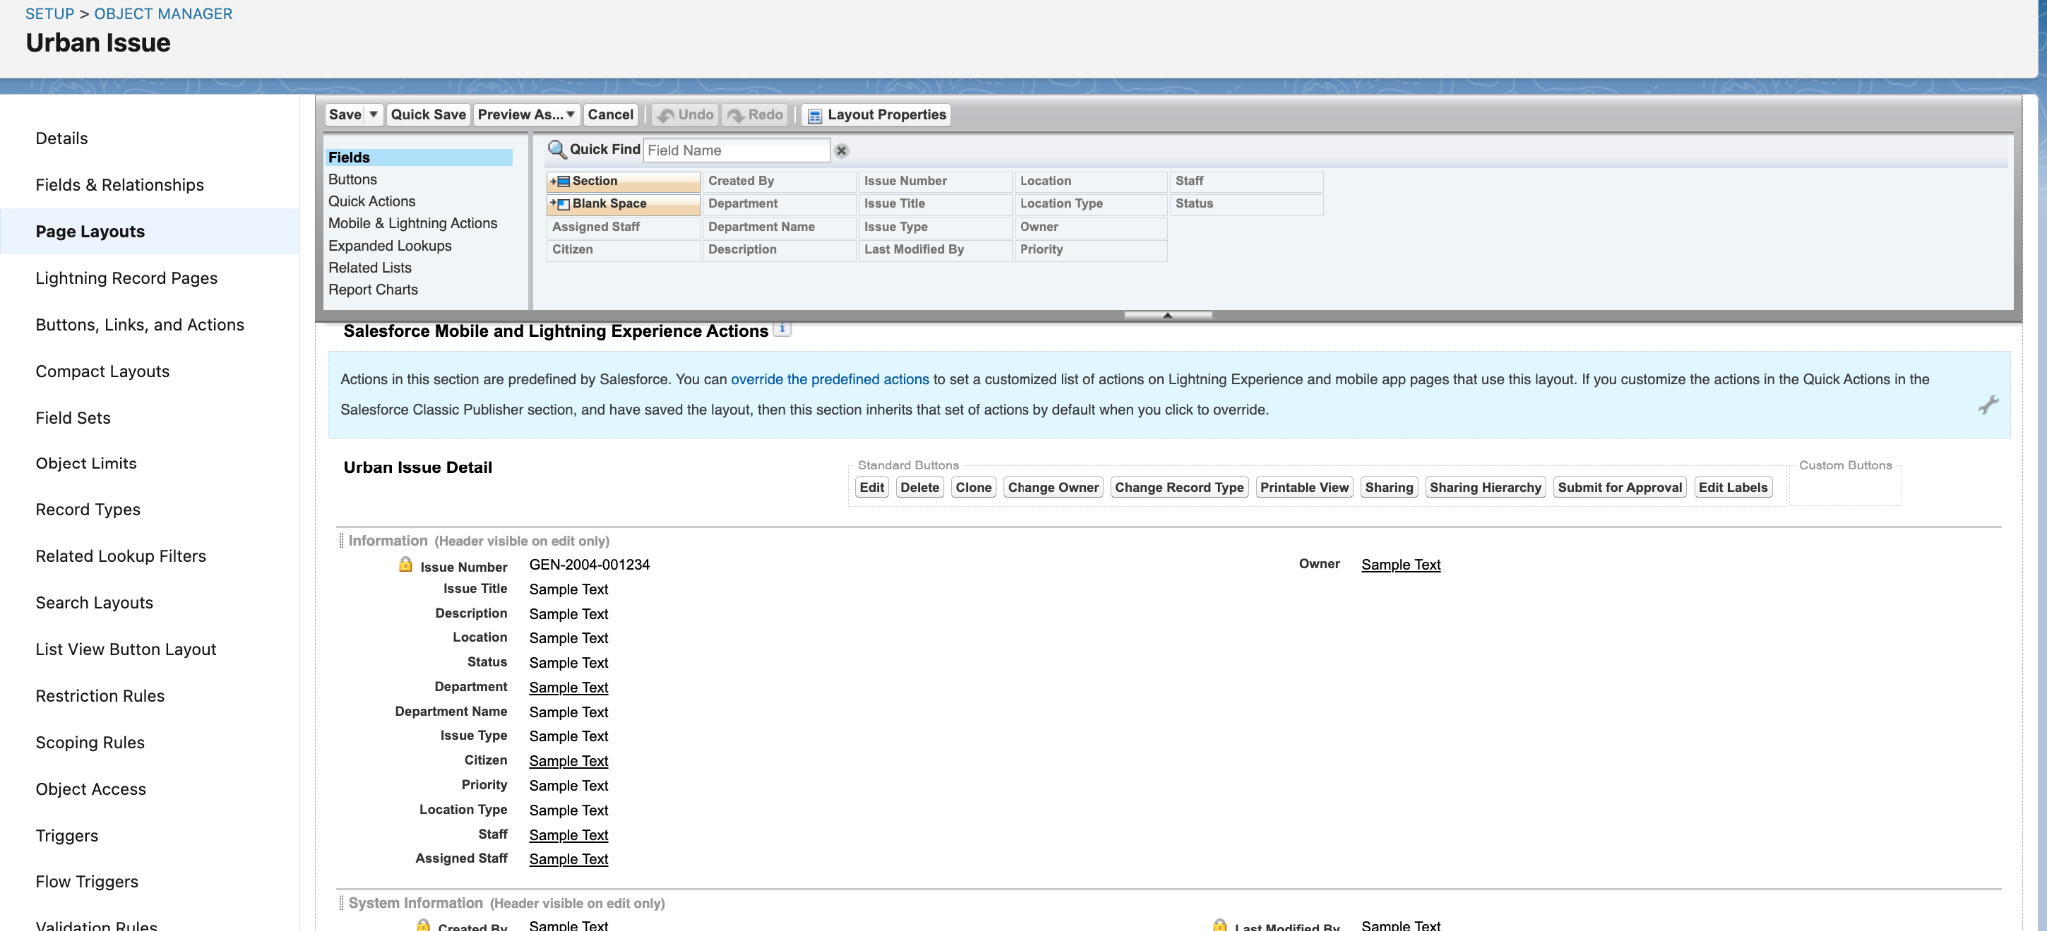

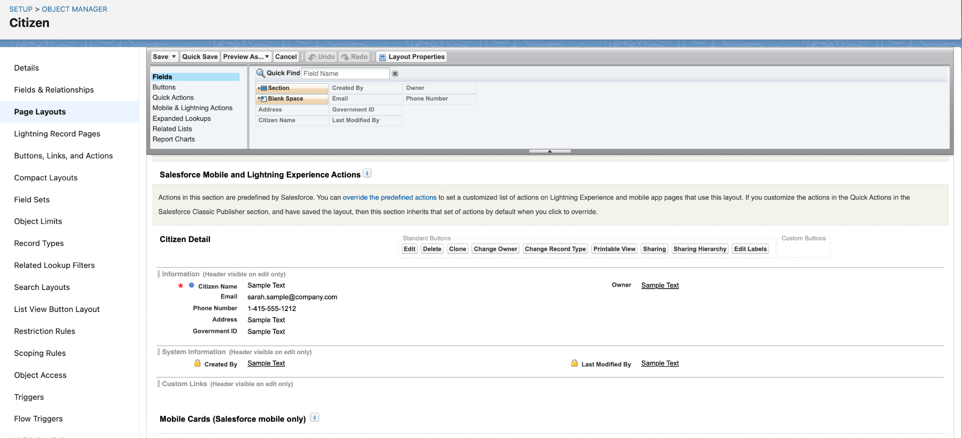

Compact Layouts:  
A compact layout was configured for each custom object to display key fields in the highlights panel and on mobile.

* *Example (Urban_Issue):* Compact layout includes Issue_Title, Status, and Department.

Record Types:  
A single record type is used for each object at this stage.  
(Future enhancement: Add record types to Urban_Issue for different issue categories or reporting sources.)

## **Data Architecture**

Schema Builder:  
The data model was visualized using Schema Builder, clearly showing:

* Department at the center with lookups from Urban_Issue.
* Citizen object connected to Feedback (and optionally Urban_Issue).
* Feedback object with lookups to both Citizen and Urban_Issue.

## 

# **PHASE 4 - Process Automation (Admin)**

## The goal of this phase is to use Salesforce's declarative tools to automate the core business logic, enforce data quality, and handle notifications for the Urban Issue Management project.

## **1. Validation Rules**

## Purpose: Ensure that Urban Issues have correct and complete data before saving.

## Object: Urban_Issue__c

## Implemented Examples:

## Location Required

## Formula: ISBLANK(Location__c)

## Error Message: "Location is required for all Urban Issues."

## 

## 

## Object: citizen__c

## Implemented Examples:

## Require_Government_ID

## Formula: ISBLANK( Government_ID__c )

## Error Message: “Government ID is required".

## 

## 

## **2. Workflow Rules**

## Purpose: Automate simple field updates without code.

## Object: Urban_Issue__c

## Implemented Example:

## Auto-update Status to "In Progress" when Priority = Urgent

## Rule Criteria: Priority__c equals 'Urgent'

## Workflow Action: Field Update → Status = "In Progress"

## 

## **3. Flow Builder (Record-Triggered Flow)**

## Tool: Flow Builder (Record-Triggered Flow)

## Objective: Automate core business logic for Urban Issues.

### **Implemented Flows:**

#### **A. Auto-Assignment of Issues to Departments**

## Trigger: When Urban Issue record is created.

## Logic:

## Decision element checks Issue Type.

## For each Issue Type, uses Get Records to find the correct Department.

## Assignment sets Department lookup and Department Name on Urban Issue.

## Update Records element saves changes.

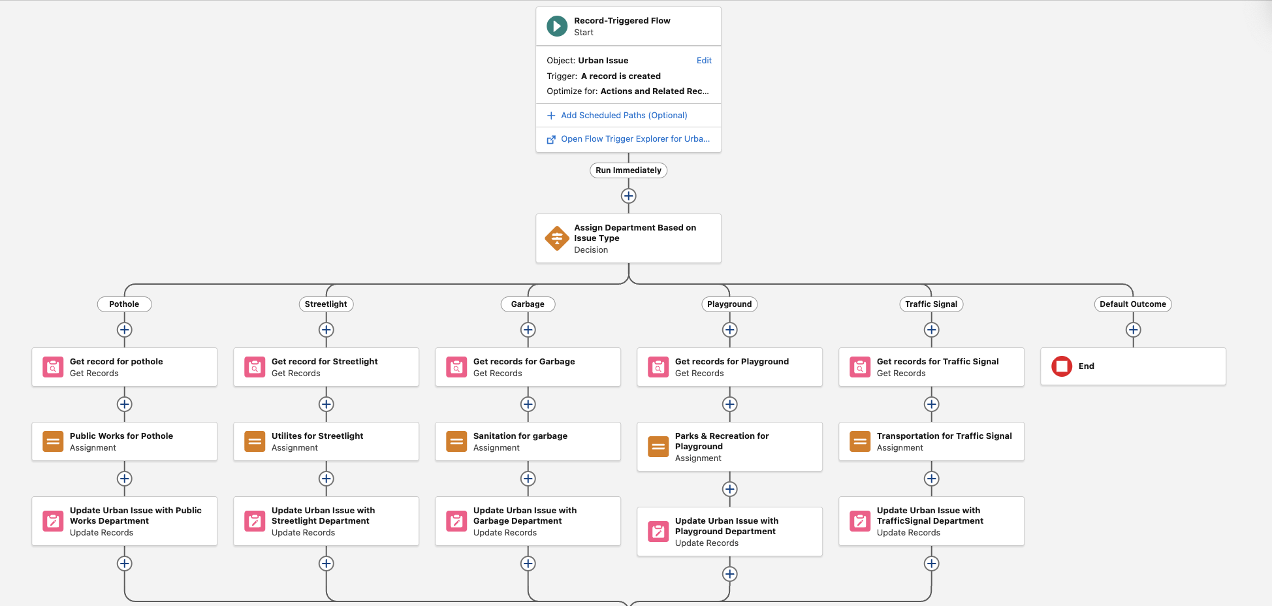

#### **B. Email Notification to Citizen**

## Trigger: When Urban Issue record is created.

## Logic:

## Action: Sends a confirmation email (using Send Email or Email Alert) to the citizen’s email address with the Issue reference number.

#### **C. Priority Assignment Using Location Type**

## Trigger: After department assignment in the same flow.

## Logic:

## Decision element evaluates Location Type.

## Assignment sets Priority to "Urgent", "High", "Medium", or "Low" per the mapping.

## Update Records saves the new Priority.

## 

## **4. Approval Process**

## Purpose: Require supervisor approval for critical Urban Issues.

## Object: Urban_Issue__c

## Implemented Example:

## Entry Criteria: Priority = Urgent

## Approver: Supervisor (selected automatically or by submitter)

## Actions:

## On Submission: Notifies approver by email.

## On Approval: Updates Status to "Approved".

## On Rejection: Updates Status to "Rejected".

## 

## **5. Email Alerts**

## Purpose: Send email notifications as part of the Approval Process and Flows.

## Implementation:

## Created Email Templates for approval requests and confirmation emails.

## Email Alerts configured in Approval Process:

## On submission: Notifies approver.

## On approval/rejection: Notifies submitter.

## Email sent to citizen on issue submission (via Flow).

## **6. Field Updates**

## Purpose: Update key fields as part of automation.

## Implementation:

## Used in Workflow Rule and Approval Process to update Status.

## Used in Flows to set Department, Department Name, and Priority.

## **7. Tasks**

## Purpose: Create follow-up activities for urgent/high Urban Issues.

## Status: Attempted in Process Builder, but skipped for now due to cross-object assignment limitations. Future Recommendation: Implement via Flow for advanced logic.

# **Phase 5: Apex Programming – Implementation Documentation**

## **Overview**

In Phase 5, we implemented advanced Salesforce automation for the Urban Issue tracking system using Apex programming. This phase covers the creation of custom logic for business processes that go beyond point-and-click tools, ensuring robust, scalable, and maintainable solutions.

### **Classes & Objects**

* Implemented the UrbanIssueTriggerHandler Apex class to encapsulate all trigger-related business logic.
* Custom objects such as Urban Issue, Staff, and Department were used for data modeling.

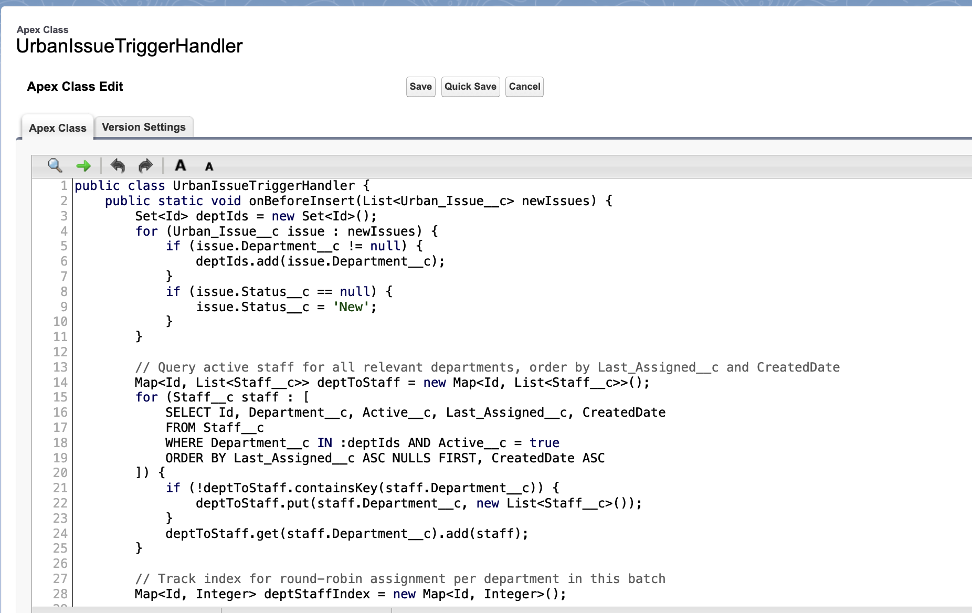

### **Apex Triggers**

* Developed the UrbanIssueTrigger on the Urban Issue object to automate logic during record insert operations.
* The trigger uses both before and after insert contexts as required.

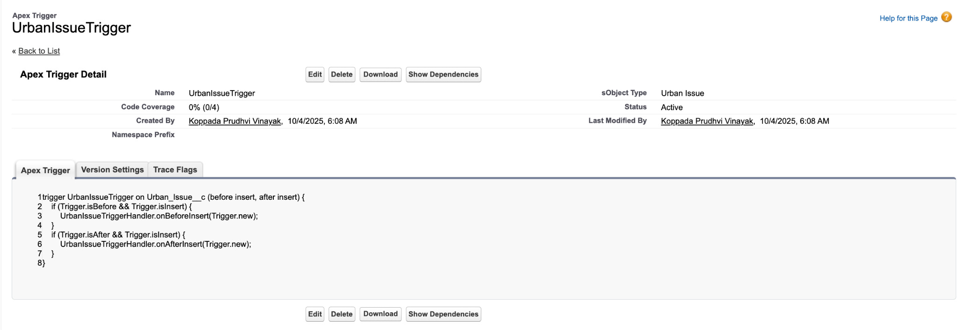

### **Trigger Design Pattern**

* Adopted the trigger handler pattern by separating logic into the handler class, keeping triggers clean and maintainable.
* All trigger events delegate processing to the handler class methods.

### **SOQL (Salesforce Object Query Language)**

* Utilized SOQL within the handler class to efficiently query related Staff and Department data needed for automation and assignment rules.

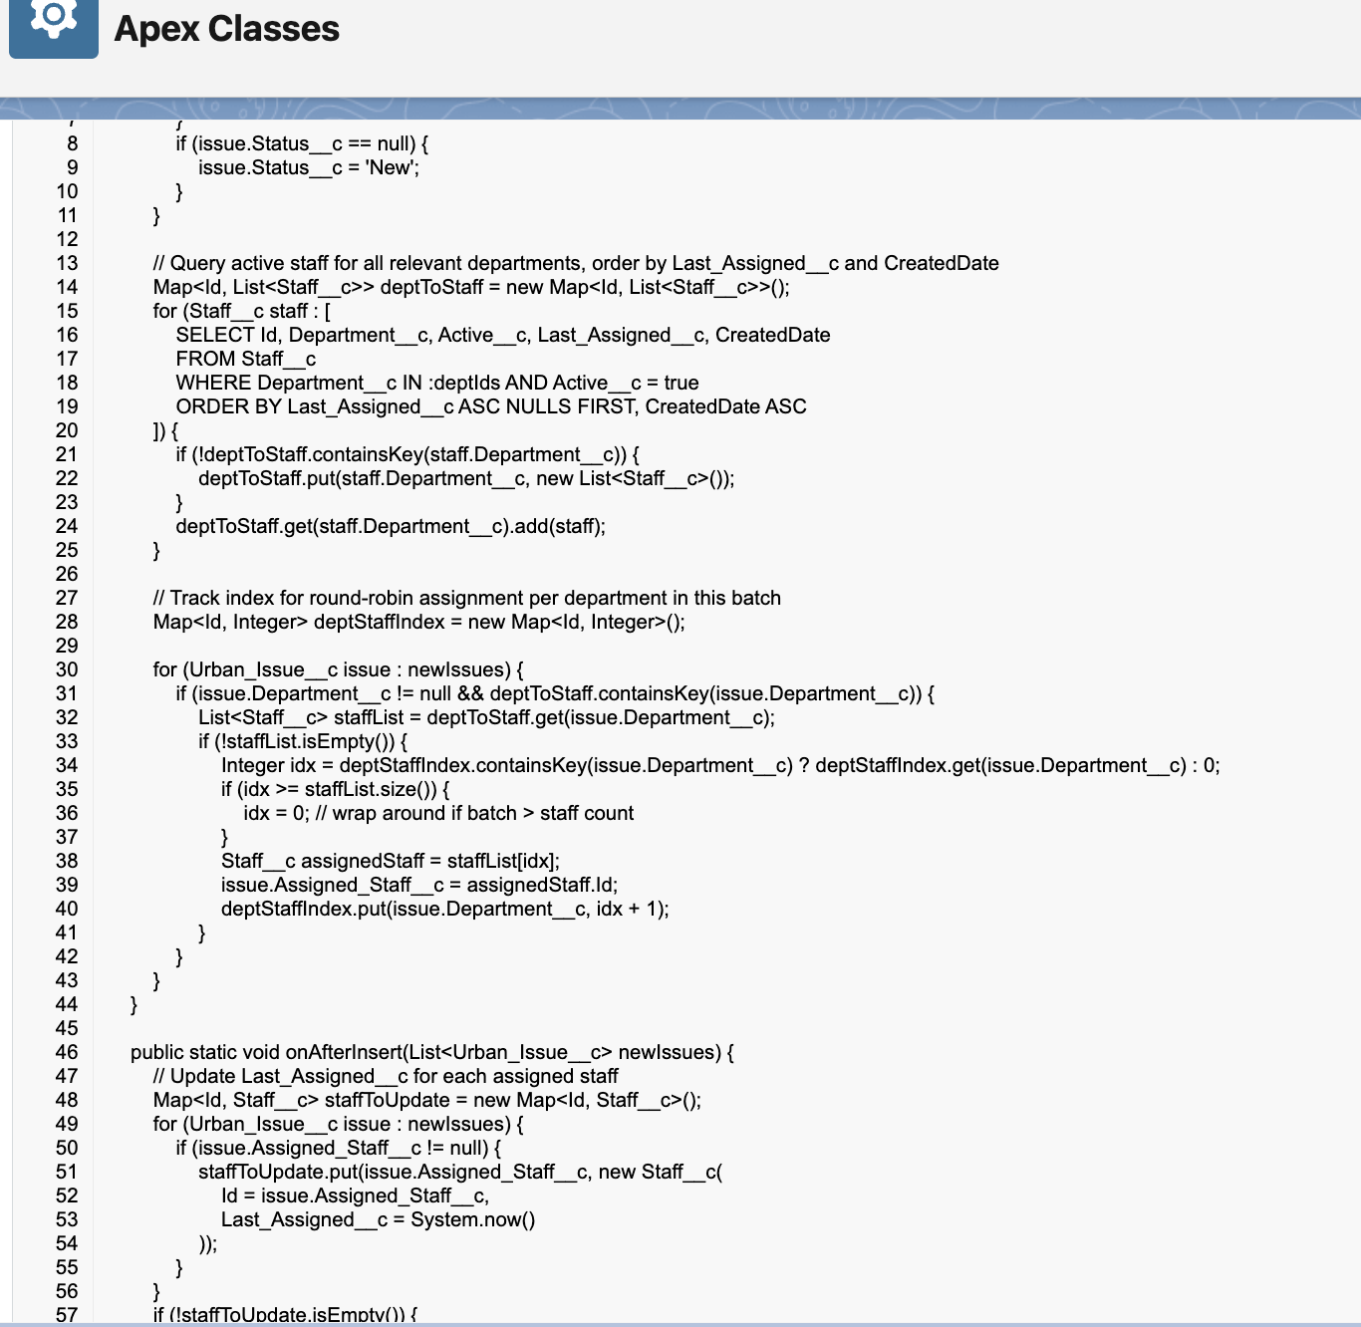

### **Collections: List, Set, Map**

* Used Lists, Sets, and Maps in the handler for bulk processing, round-robin staff assignment, and efficient data handling.

### **Control Statements**

* Incorporated for-loops, if-else statements, and other control flow structures to implement business logic in Apex.

### **Batch Apex**

* Created the UrbanIssueBatchClose Batch Apex class to process and update large volumes of Urban Issue records (e.g., closing issues older than 30 days in bulk).

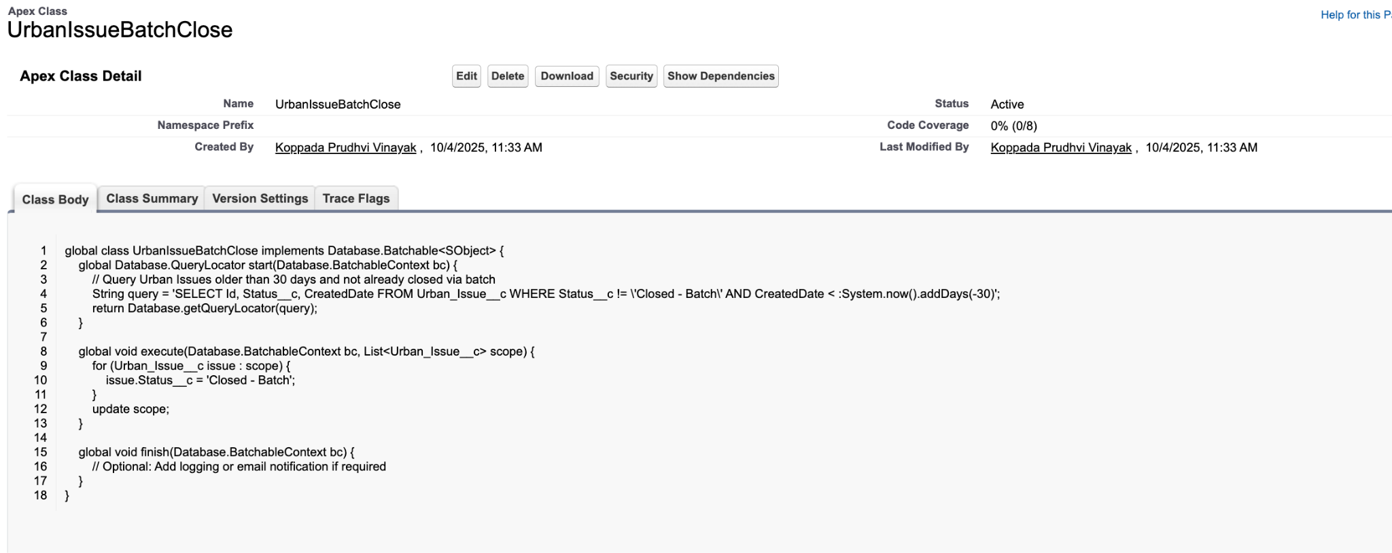

### **Scheduled Apex**

* Implemented the UrbanIssueBatchScheduler class, enabling the batch job to run automatically on a scheduled basis (e.g., weekly or nightly cleanup).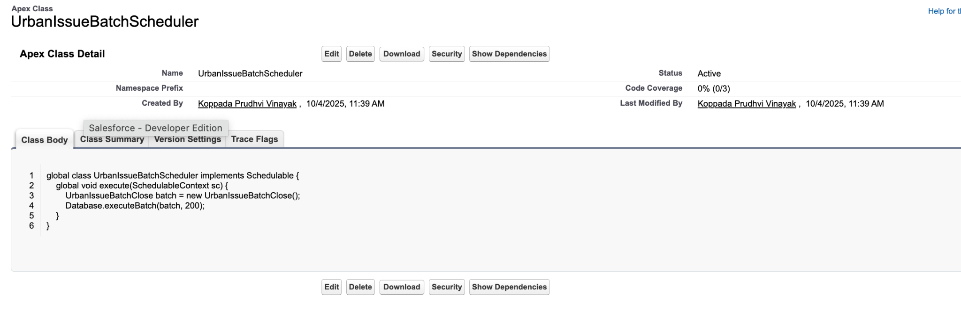

### **Exception Handling**

* Applied try-catch blocks within handler methods to gracefully handle errors and maintain data integrity.

### **Test Classes**

* Developed comprehensive test classes such as UrbanIssueTriggerHandlerTest to ensure logic coverage, data integrity, and successful deployment to production.

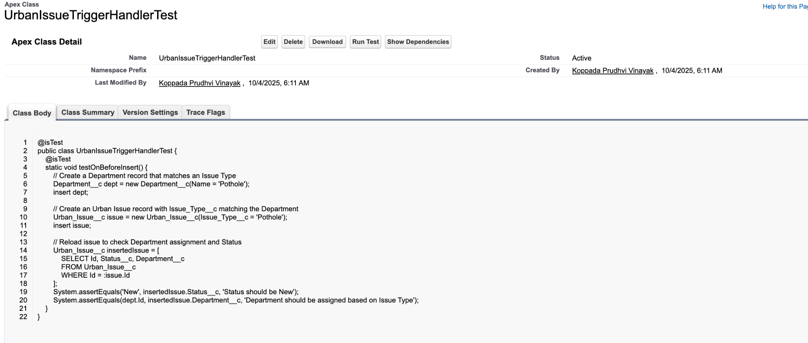

# **PHASE 6 - User Interface Development**

This phase focuses on building a responsive and intuitive user interface using the Lightning App Builder, custom record pages, tabs, the utility bar, and custom Lightning Web Components (LWC) for the Urban Issue Management system.

## **Lightning App Builder**

The Lightning App Builder was the central tool for assembling the app’s user interface declaratively.

* App Creation: A dedicated Salesforce Lightning App was created to serve as the workspace for managing Urban Issues and Citizens.
* Home Page & Record Pages: The Home Page and Record Pages for custom objects (Citizen, Urban Issue) were customized to include relevant components and layouts for optimal user experience.
* Utility Bar: The app’s utility bar was set up to provide always-accessible tools. A custom utility item can be included, such as the Citizen Issue Submit component, for quick access to core functionality.

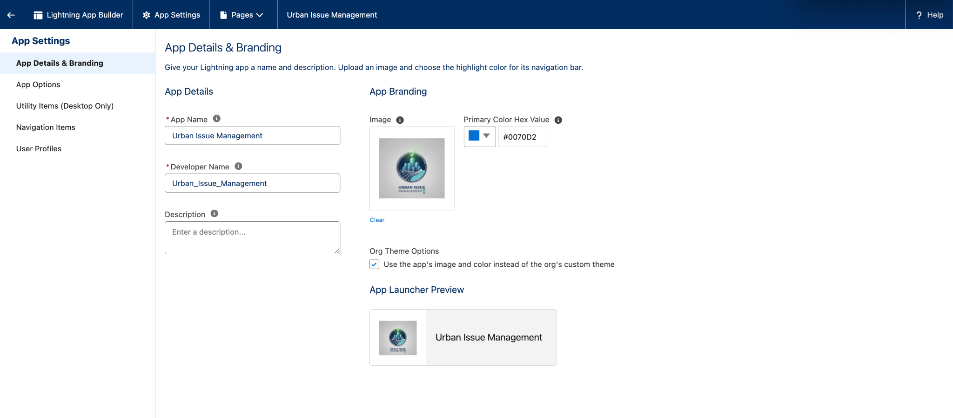

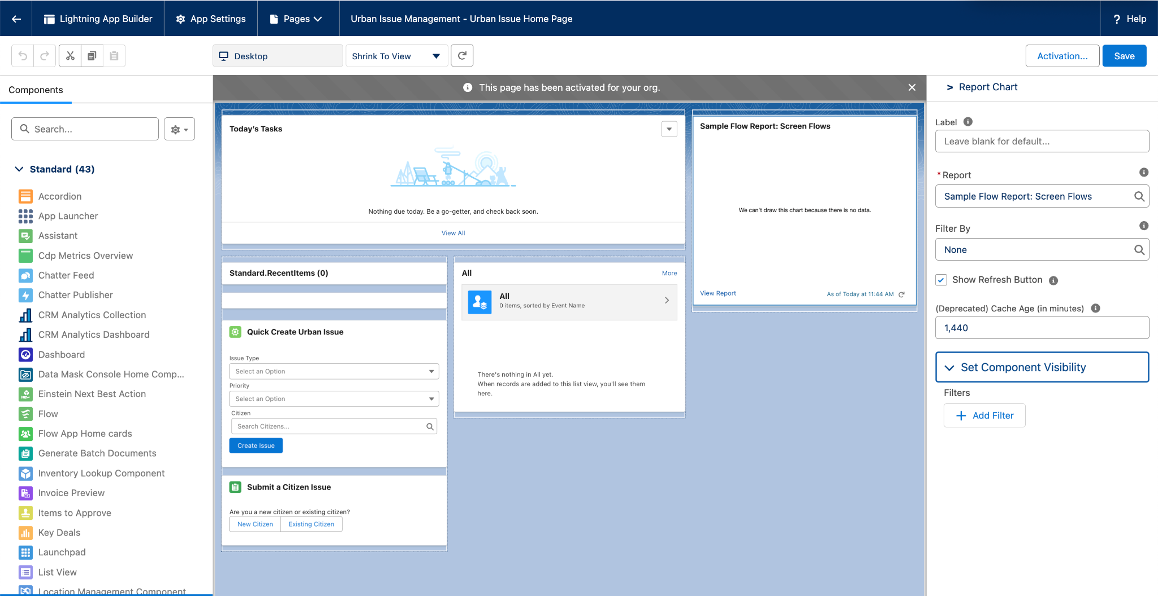

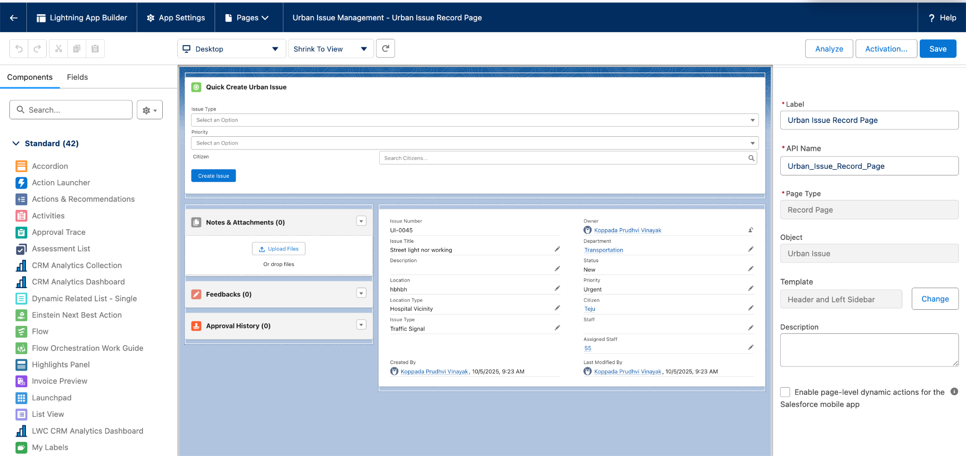

## **Record Pages & Tabs**

* Enhanced Record Pages: Custom Record Pages were configured for the Citizen and Urban Issue objects. These pages display key fields, related lists, and surface custom LWCs for data entry or quick actions.
* Custom Tabs: Tabs for "Citizens," "Urban Issues," and other objects were added to the app’s navigation, making it easy for users to switch between major data entities..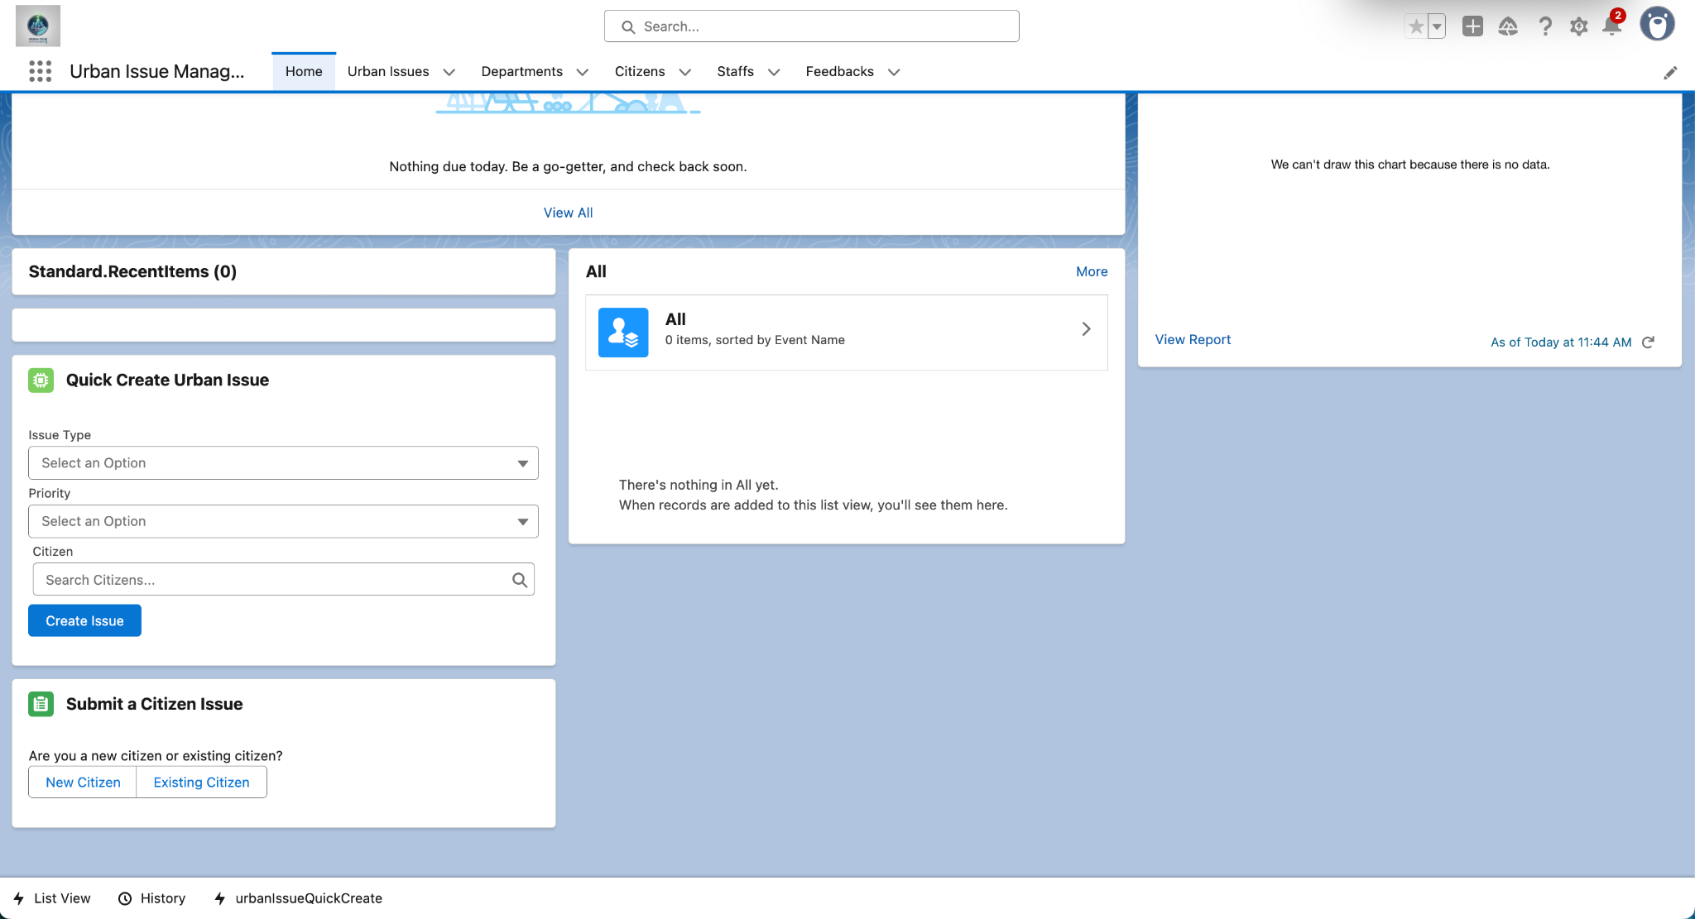

## **Lightning Web Components (LWC)**

Custom Lightning Web Components were developed to streamline and enhance user interactions:

* Citizen Issue Submit:  
  A multi-step LWC that guides users through either creating a new Citizen or selecting an existing one, then submitting a new Urban Issue. The form dynamically presents fields for both entities and performs validation before saving.
* Apex with LWC:  
  These LWCs communicate with Apex controllers to create, search, and relate records. Apex methods are @AuraEnabled and securely handle DML operations.
* Imperative Apex Calls:  
  The LWC uses imperative Apex calls for actions such as creating a Citizen or Urban Issue, and for searching existing Citizens based on input.
* Picklist Support:  
  The Urban Issue section of the LWC features dynamic picklists for fields like Issue Type and Location Type, mirroring business requirements.

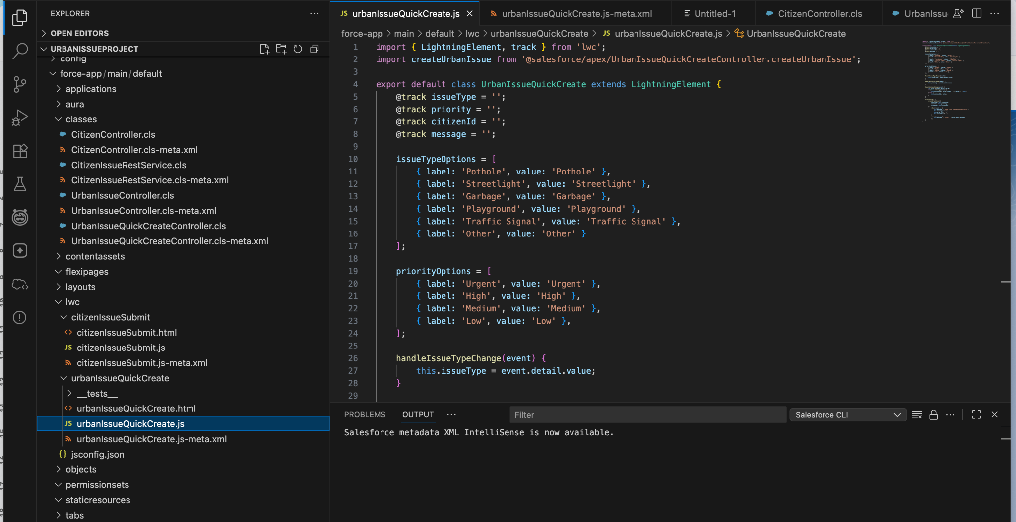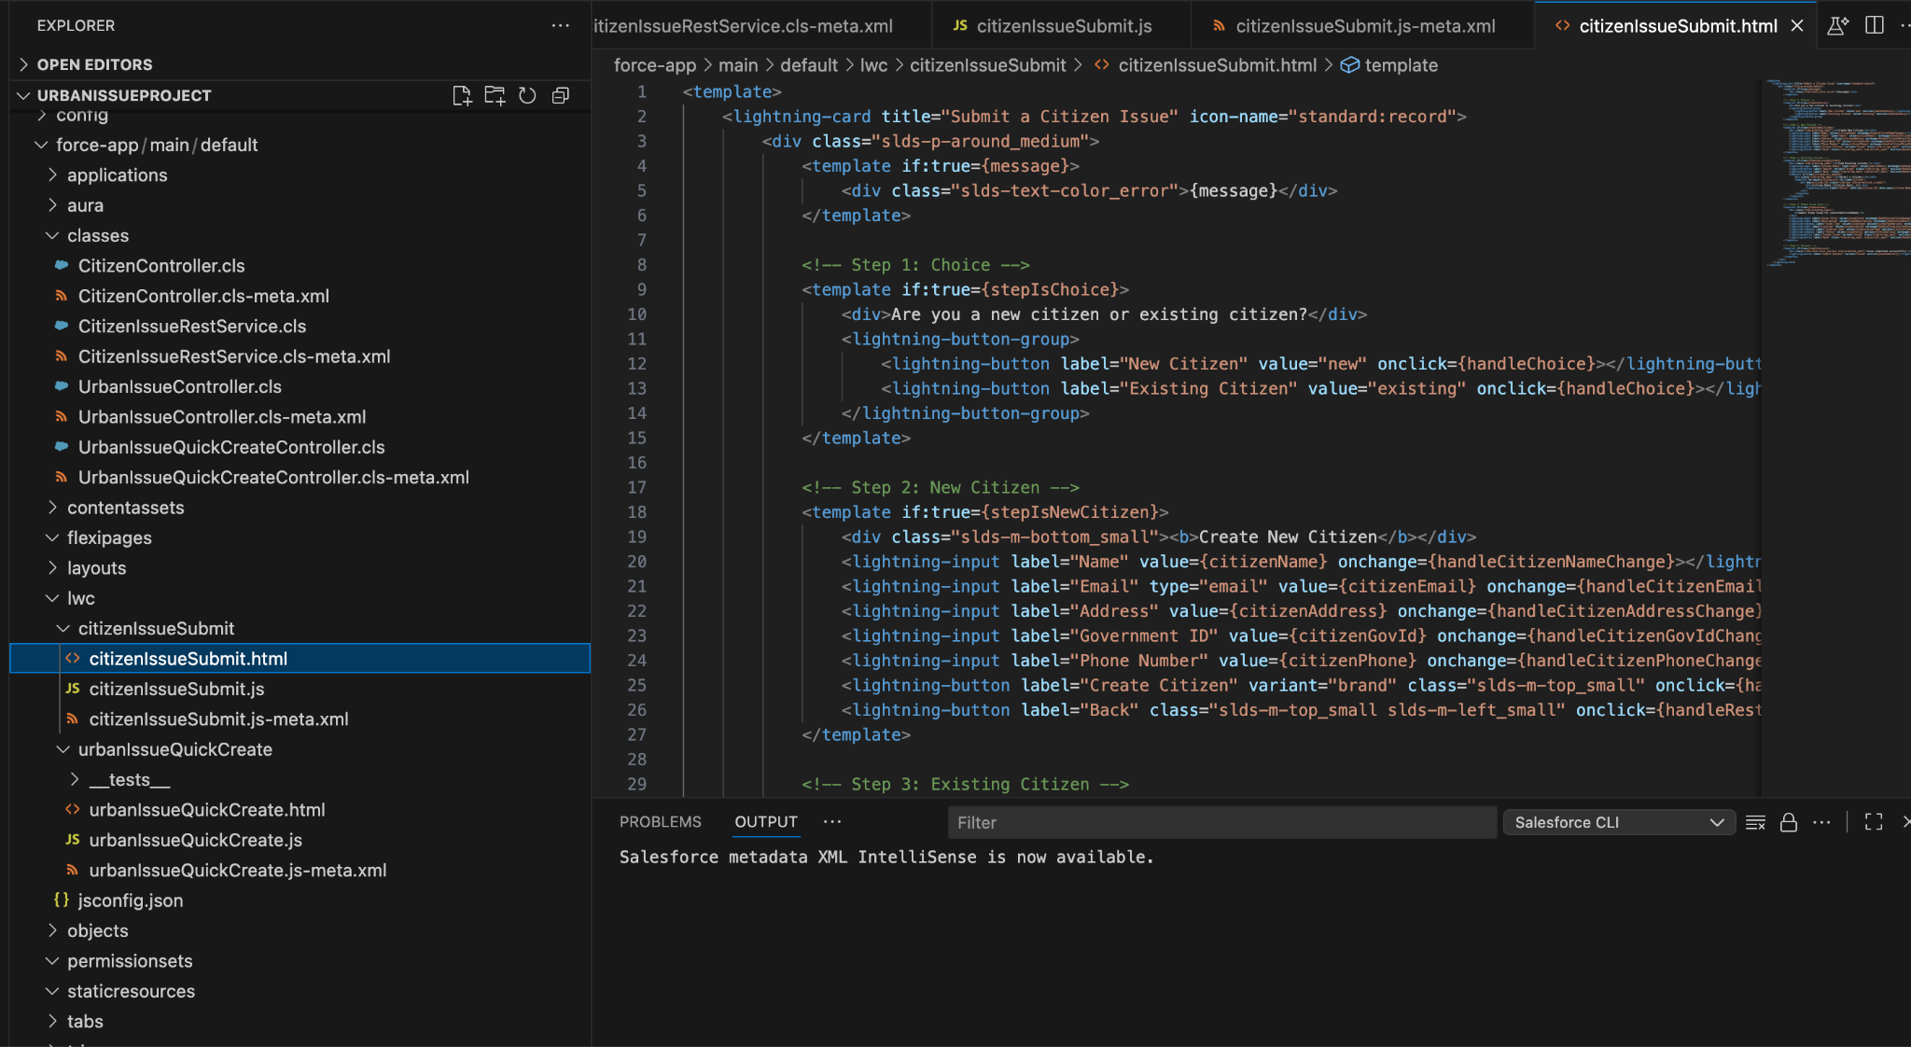

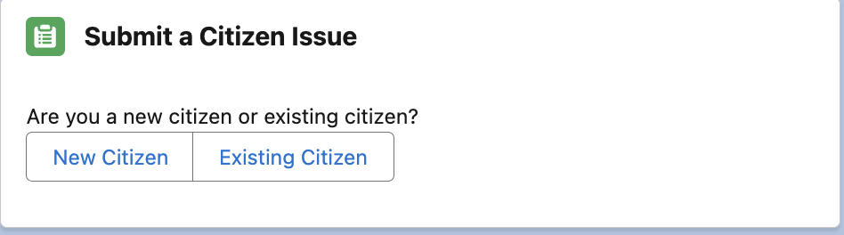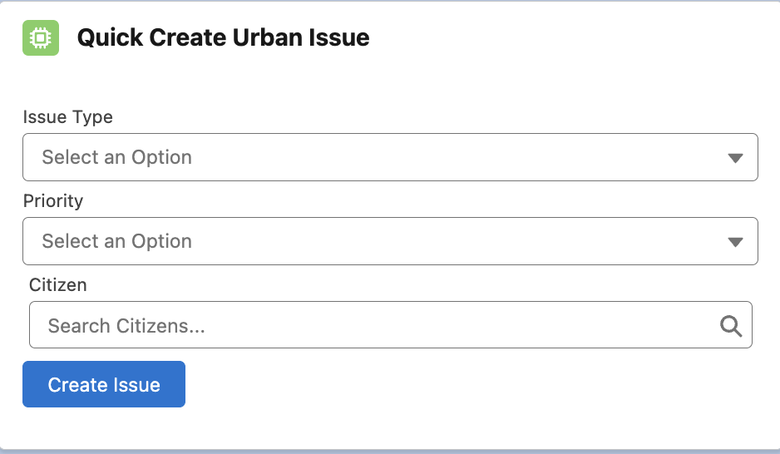

**Utility Bar**

* Utility Bar is set up in the App Manager for your custom app.
* Standard utilities (like History, Notes) and/or custom LWCs (like Citizen Issue Submit) can be accessed at the bottom of the screen.



## **Apex with LWC & Imperative Apex Calls**

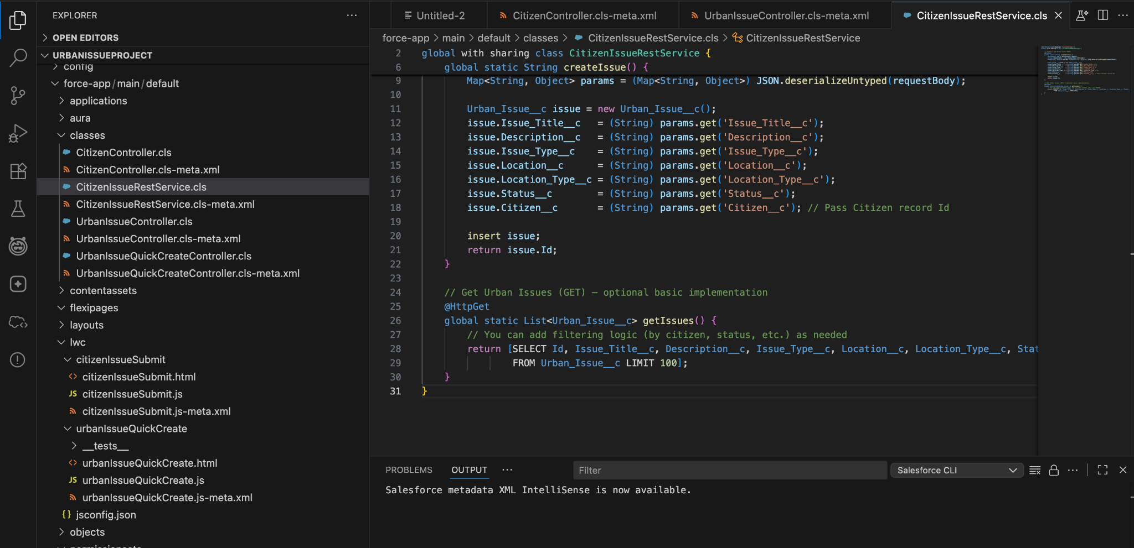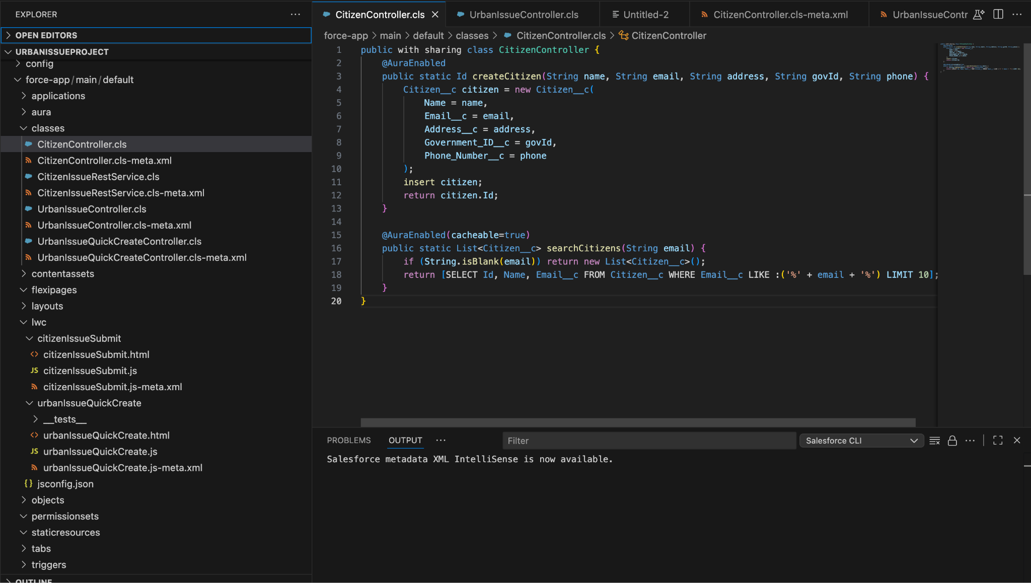

# **Phase 7: Integration & External Access — Implementation Documentation**

This document details each integration and external access concept implemented in Phase 7 of the Urban Issue Management Salesforce project. For each, a clear use case is provided, followed by a summary of the implementation and notes on where to add screenshots.

## **1. Apex REST Web Service**

Use Case:  
To allow external platforms such as a government website, mobile app, or third-party service to create or view Urban Issues directly in Salesforce, we exposed a secure REST API. This enables seamless integration with external systems, automating issue submissions and status tracking without requiring direct Salesforce access for external users.

Implementation:  
We developed an Apex class (CitizenIssueRestService) annotated with @RestResource, exposing REST endpoints to create and query Urban Issues. External systems can send HTTP requests with issue data, and Salesforce processes them securely.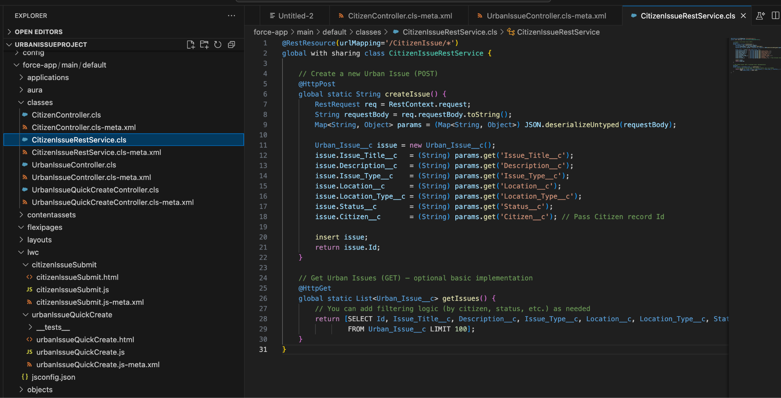

## **2. OAuth & Authentication**

Use Case:  
To ensure that only authorized and authenticated external applications can access our Salesforce REST API, we implemented OAuth 2.0 authentication. This protects sensitive data and restricts API access to trusted integrations.

Implementation:  
A Connected App was configured in Salesforce Setup, with OAuth enabled. The Connected App provides a Client ID/Secret and defines OAuth scopes, allowing external apps to request and use access tokens for secure API communication.

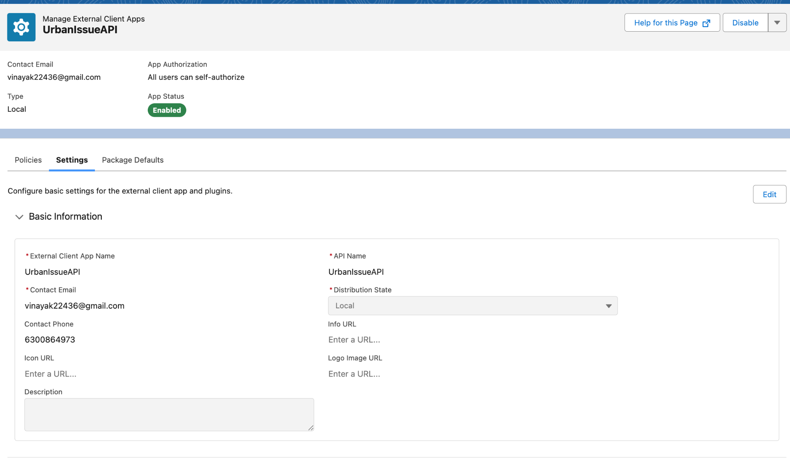

## **3. Named Credentials**

Use Case:  
When Salesforce needs to connect to external APIs (e.g., for government ID validation or external data checks), using Named Credentials allows us to securely store authentication details, simplify callout management, and centralize credential updates.

Implementation:  
A Named Credential (GovID_Verification) was created, referencing an External Credential and Principal which store the authentication method and details for the external service. This setup ensures callouts are secure, manageable, and compliant with Salesforce best practices.

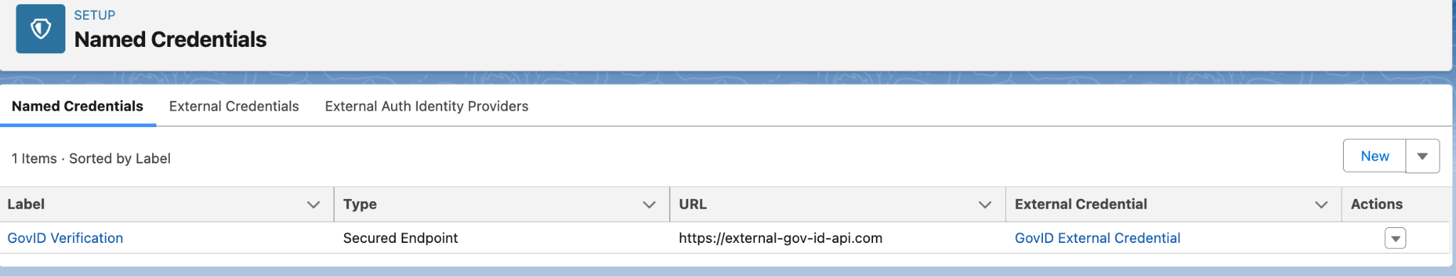

# **Phase 8: Data Management & Deployment — Implementation Documentation**

This document details each data management and deployment concept implemented in Phase 8 of the Urban Issue Management Salesforce project. For each, a clear use case is provided, followed by a summary of the implementation and notes on where to add screenshots for your records.

## **1. Data Import Wizard**

Use Case:  
To quickly and easily load bulk records (such as Citizens and Urban Issues) into Salesforce from CSV files, especially during initial setup or when migrating data from legacy systems. The Data Import Wizard provides a user-friendly interface for admins to map CSV columns to Salesforce fields and verify data before insertion.

Implementation:  
We used the Salesforce Data Import Wizard to import new Citizen and Urban Issue records. This process involved preparing a CSV file, launching the wizard, selecting the target object, mapping fields, and confirming the import.

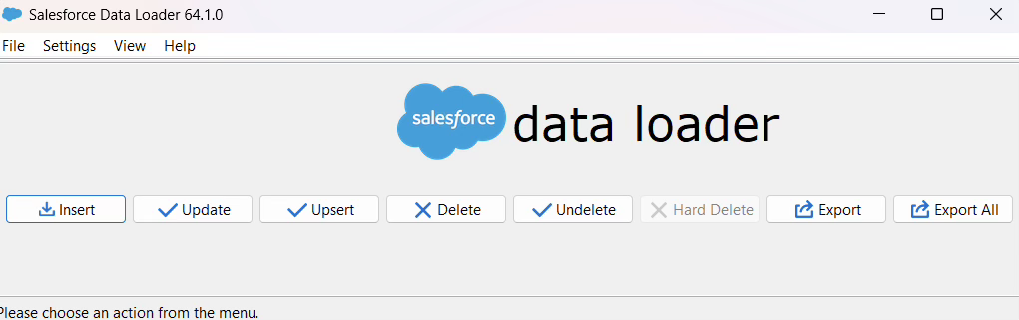

## **2. Duplicate Rules**

Use Case:  
To maintain high data quality by detecting and preventing duplicate records, such as Citizens with the same email or government ID. Duplicate Rules ensure that each record in the system is unique according to your chosen criteria, reducing confusion and redundant entries.

Implementation:  
We created custom Matching Rules based on unique fields (like Email__c or Government_ID__c) and then set up Duplicate Rules for the Citizen object. The rules were configured to either block duplicate entries or alert users when a potential duplicate is detected during data entry or import.

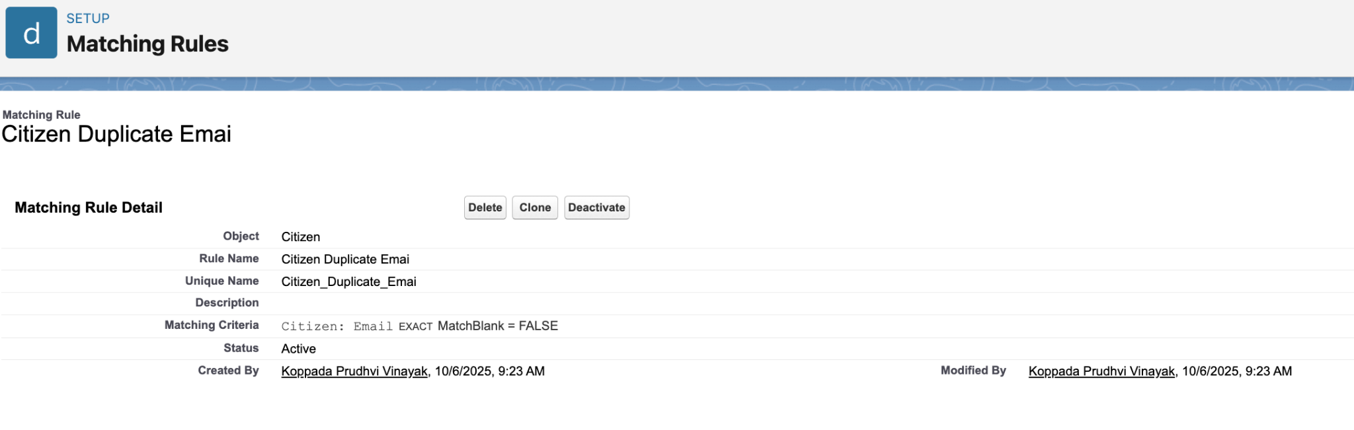

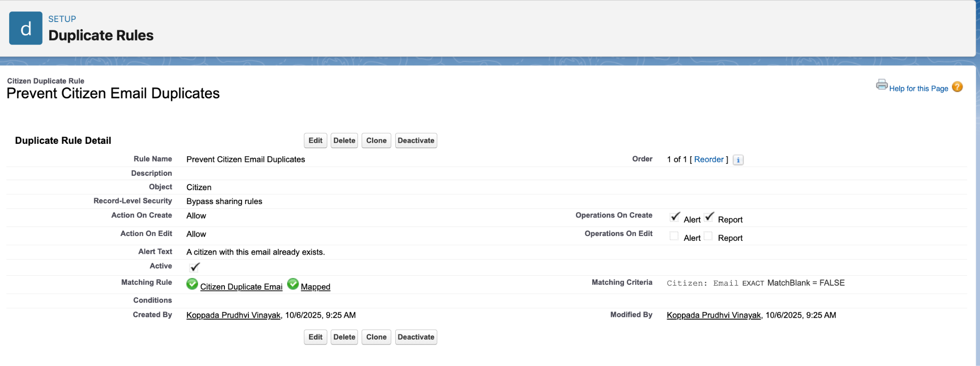

## **3. Data Export & Backup**

Use Case:  
To regularly back up Salesforce data for safety, compliance, and disaster recovery. Data Export ensures that all business-critical records can be restored or analyzed offline if needed.

Implementation:  
We scheduled regular data exports using Salesforce’s built-in Data Export tool. This included selecting all relevant objects (e.g., Citizen, Urban Issue) and setting a backup schedule (weekly or monthly). We also performed on-demand exports as needed for immediate backups.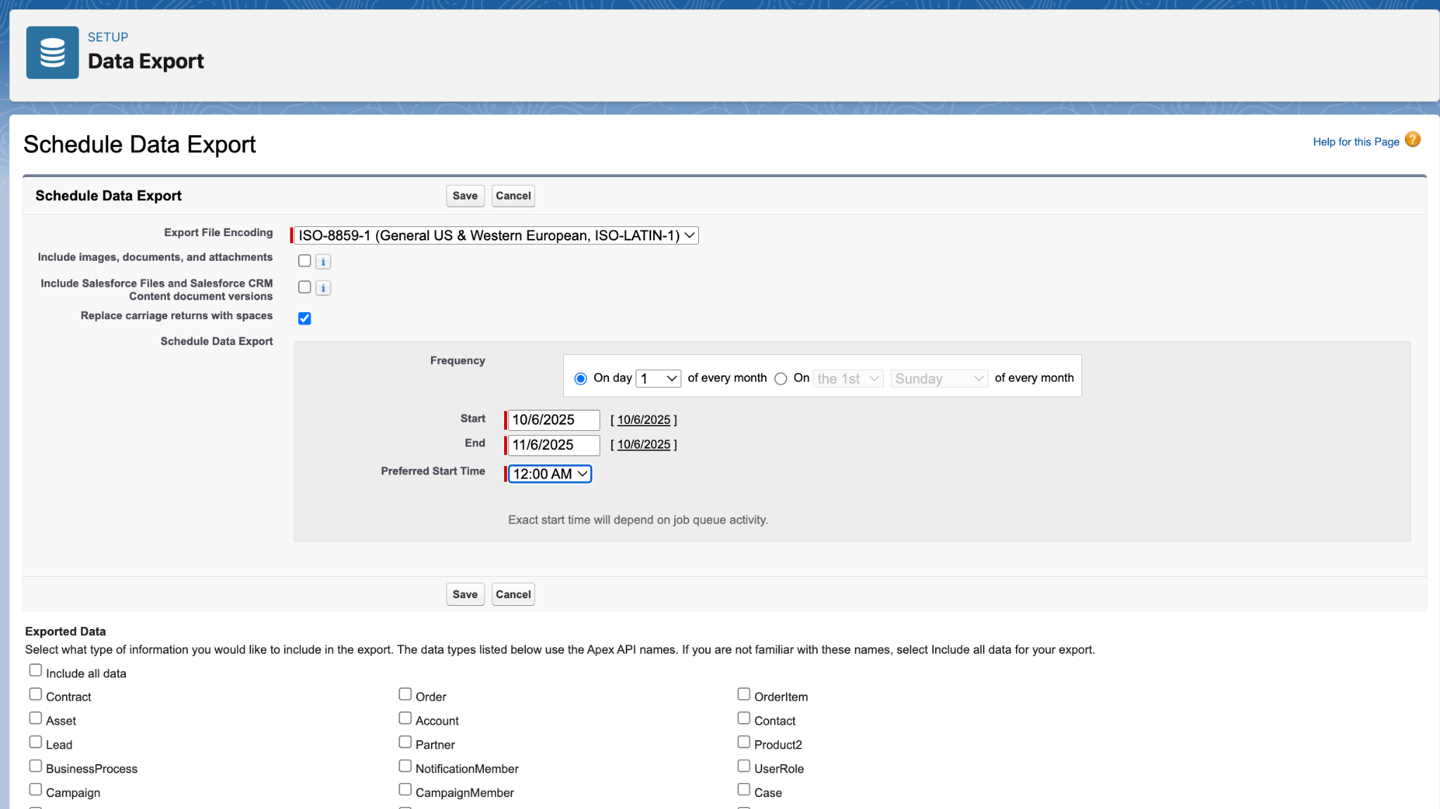

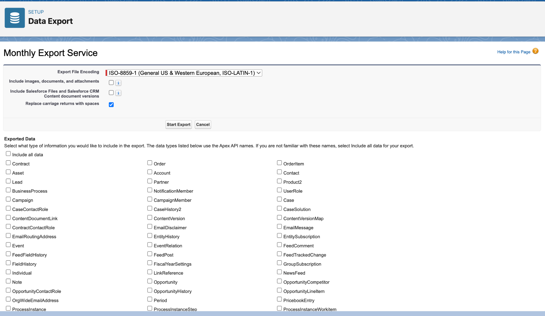

## **5. VS Code & SFDX** Use Case: For advanced/developer-driven projects, VS Code with Salesforce DX (SFDX) allows for source-driven development, version control, and more flexible deployments. SFDX is essential for teams practicing modern DevOps or continuous integration.

Implementation:  
We used VS Code with the Salesforce Extensions Pack to retrieve and deploy metadata, manage source code, and run SFDX commands for deployments between orgs.

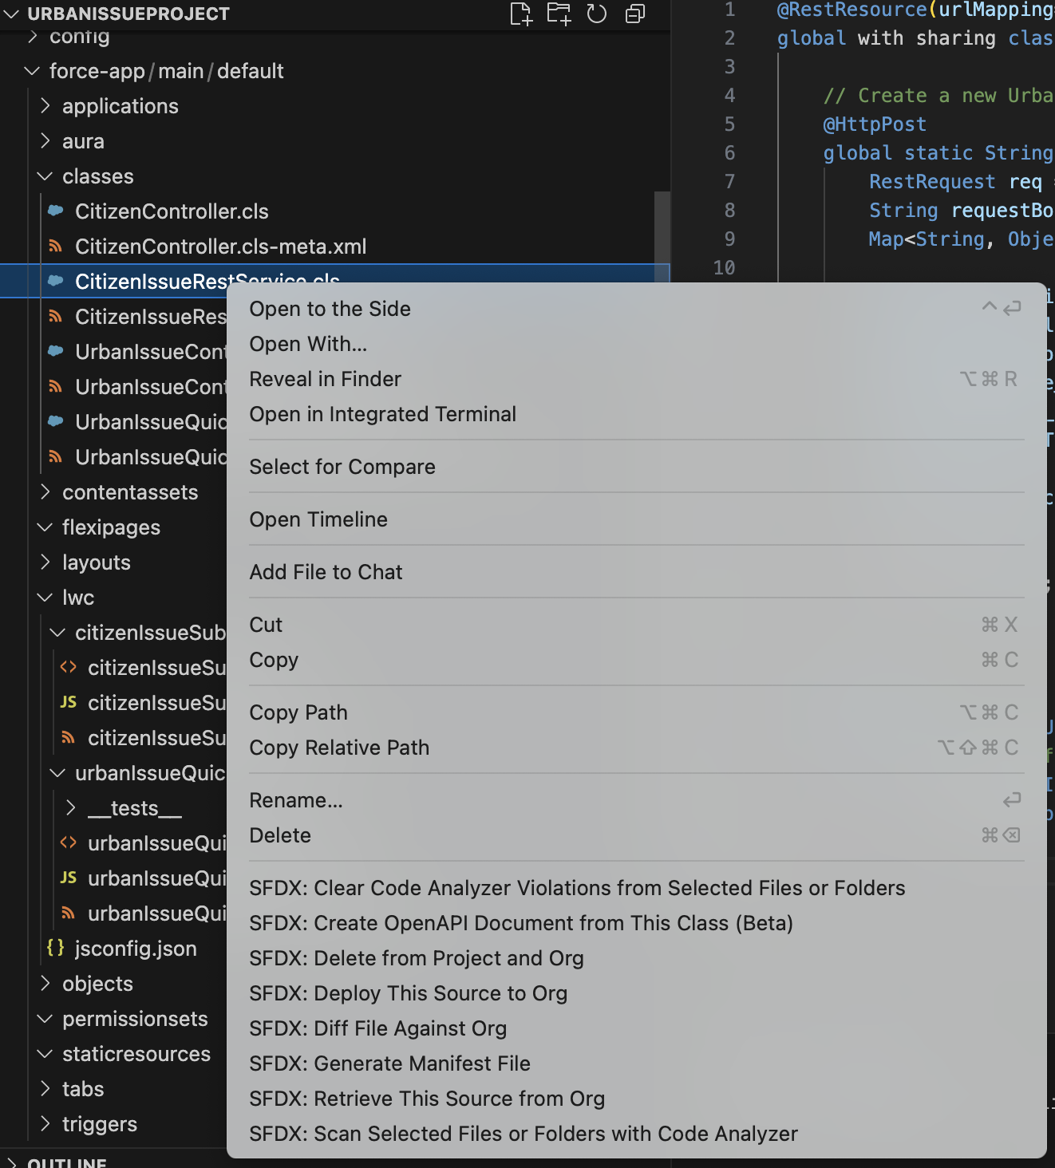

# **PHASE 9 - Reporting, Dashboards & Security Review**

This phase focused on providing actionable insights through reporting, enabling visual representation of key metrics via dashboards, and ensuring the solution is secure and ready for deployment.

### **Reporting**

Reports were created to provide visibility into the Urban Issue Management process and citizen engagement. These reports empower teams to monitor trends, identify bottlenecks, and make data-driven decisions.

Steps Taken:

* Created a custom report type, “Urban Issues with Citizens,” to enable combined reporting across Urban Issue and Citizen records.
* Built the following reports:
  + Urban Issues by Status: Shows the count of issues in each status (Open, In Progress, Closed, etc.) to monitor workflow and backlog.
  + Urban Issues by Type and Location: Displays the distribution of reported issues by type across various locations, highlighting hotspots or recurring problems.
* Grouped and filtered data as needed for actionable views.
* Added charts to reports for quick visualization.

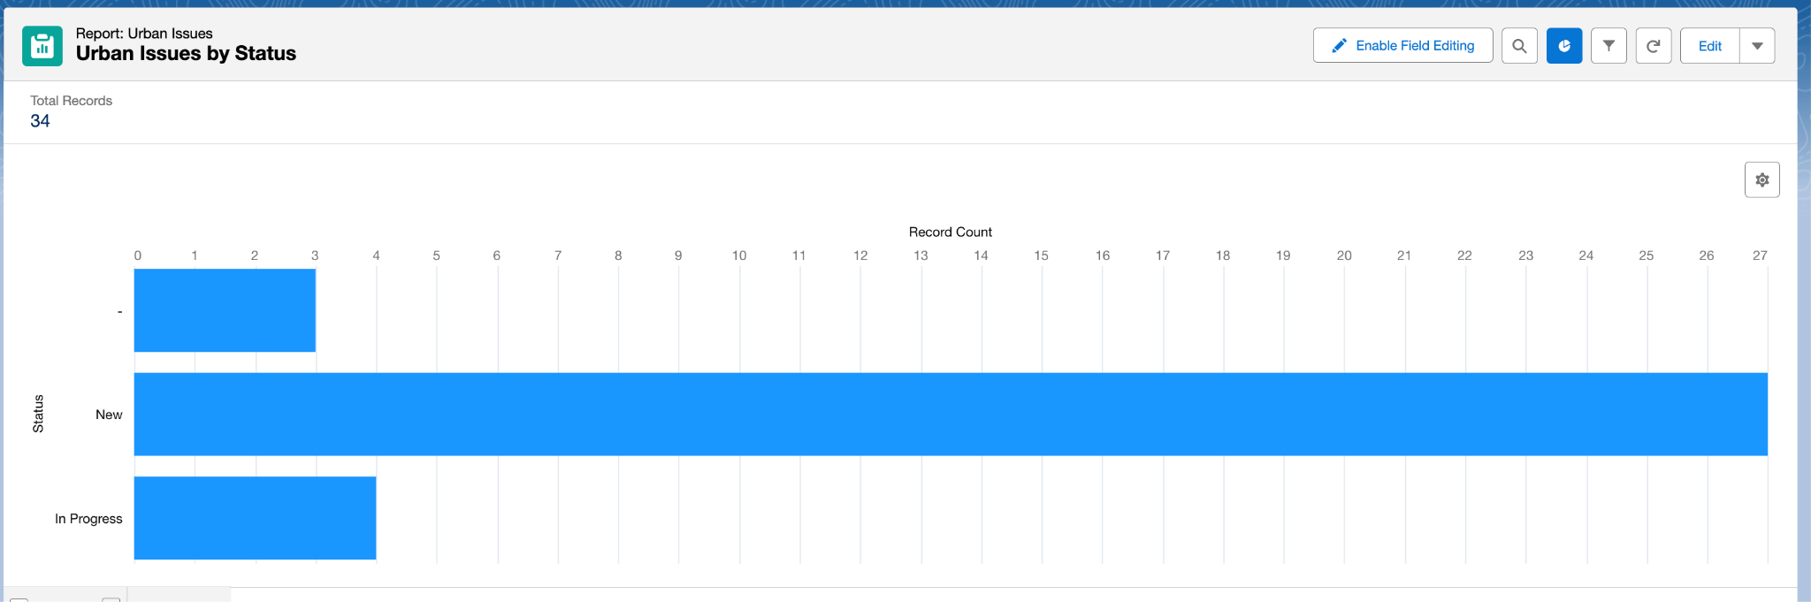

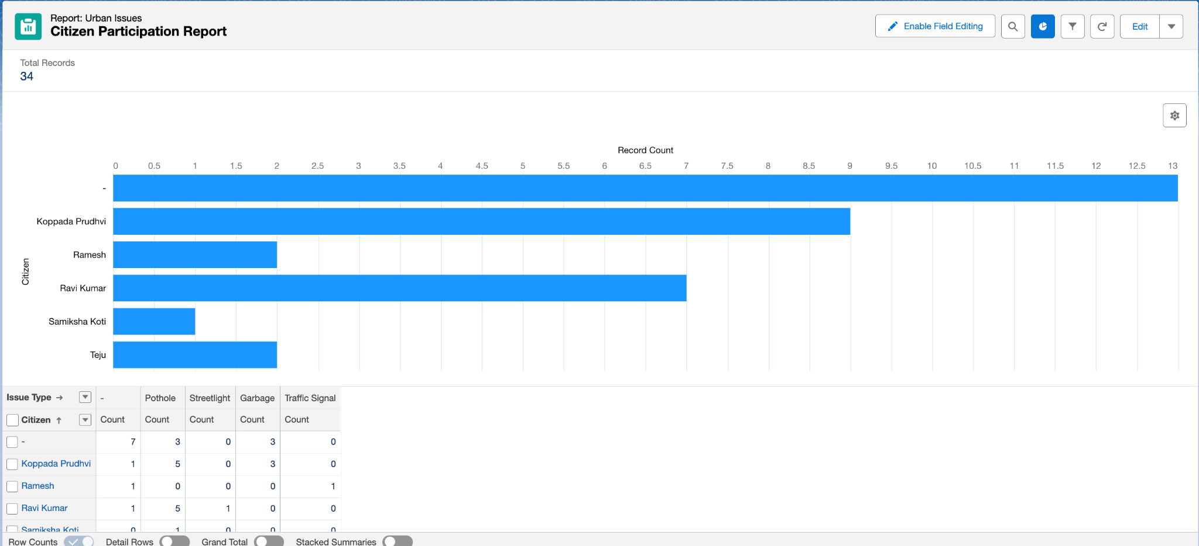

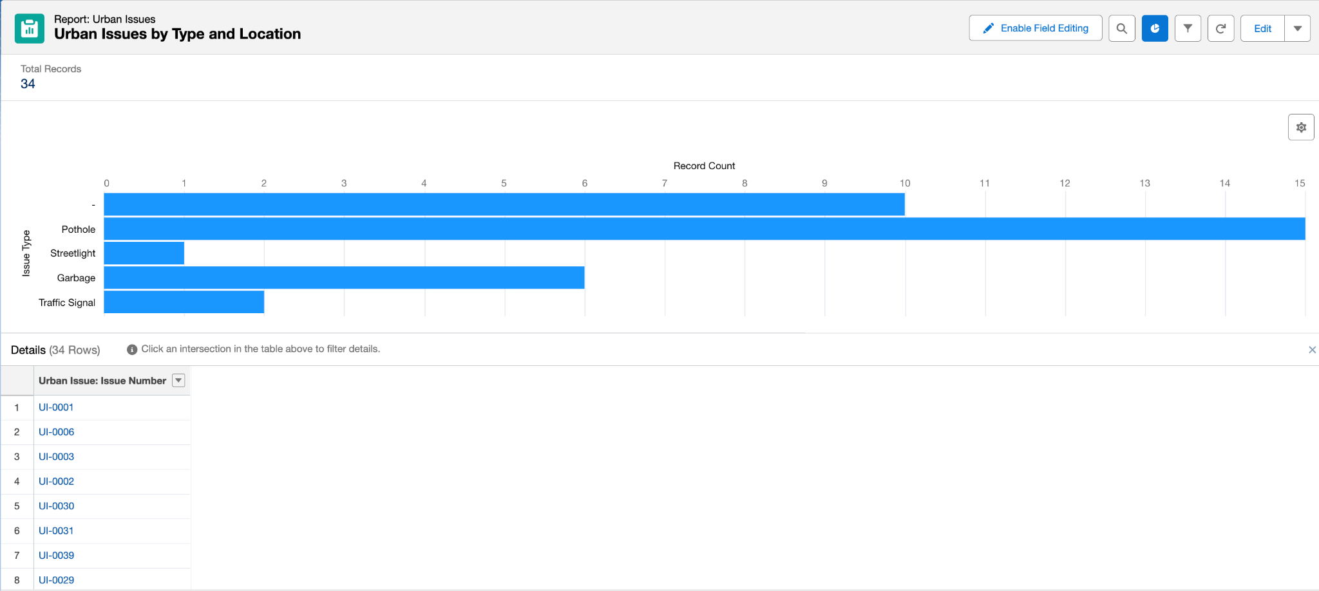

### **Dashboards**

Dashboards were implemented to provide at-a-glance insights for stakeholders, combining multiple reports and key performance indicators onto a single screen.

Steps Taken:

* Created a dashboard titled “Urban Issue Management Overview.”
* Added components using the previously built reports:
  + Pie chart for Urban Issues by Status.
  + Stacked bar chart for Urban Issues by Type and Location.
* Arranged and formatted dashboard components for clarity and impact.

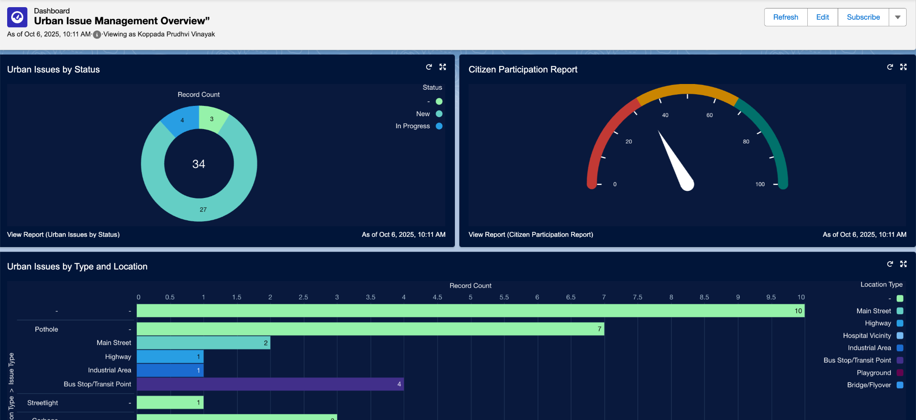

### **Security Review**

### A final review of the security settings was conducted to ensure the principle of least privilege was enforced across all user profiles in the Urban Issue Management application.

### **Field Level Security:** The field-level security for the Citizen, Urban Issue, and related custom profiles was meticulously reviewed and configured. Access to sensitive fields—such as government identification numbers and contact details—was restricted so that users can only view or edit information relevant to their specific roles (e.g., city staff, department head).

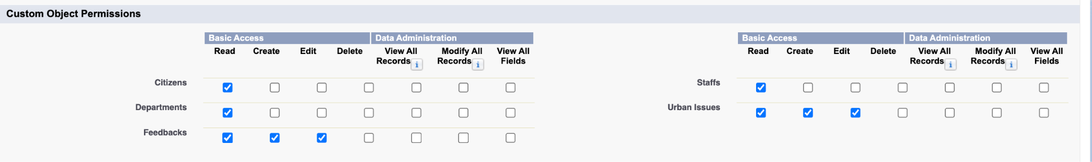

### **Sharing Settings:** The Organization-Wide Defaults (OWD) and Sharing Rules for the Citizen and Urban Issue objects were examined to confirm that data visibility is appropriately limited. Only authorized users can access or modify records, with sharing rules established to grant broader access only when necessary and as defined in earlier phases.

### 

# **Phase 10: Quality Assurance Testing & Conclusion**

This phase ensures that every Salesforce feature in the Urban Issue Management System functions as intended, is user-friendly, and meets business requirements. Comprehensive testing validates system reliability, data integrity, and user experience prior to go-live.

## **Quality Assurance Testing**

Testing Approach:  
For each feature—such as record creation, approval processes, automated flows, triggers, validation rules, reporting, and dashboard visuals—test cases were prepared. Each test case documents the scenario, input steps, expected outcome, actual outcome, and includes screenshots as evidence.

### **Sample Test Case Structure**

**Use Case / Scenario**:  
Citizen submits a new Urban Issue, triggering automatic assignment and notification.

Test Steps (with Input):

1. Navigate to the “Submit Issue” Lightning Web Component or Urban Issue record page.
2. Enter Citizen details (e.g., Name: Priya Singh, Email: priya@email.com, Gov ID: GOV999).
3. Enter Urban Issue details (Type: Pothole, Location: Main Street, Description: “Large pothole near intersection”).
4. Click “Submit”.

Expected Result:

* A new Citizen record is created (if new).
* An Urban Issue record is created with assigned Department and auto-generated Issue Number.
* Status is set to “New”.

Actual Result:

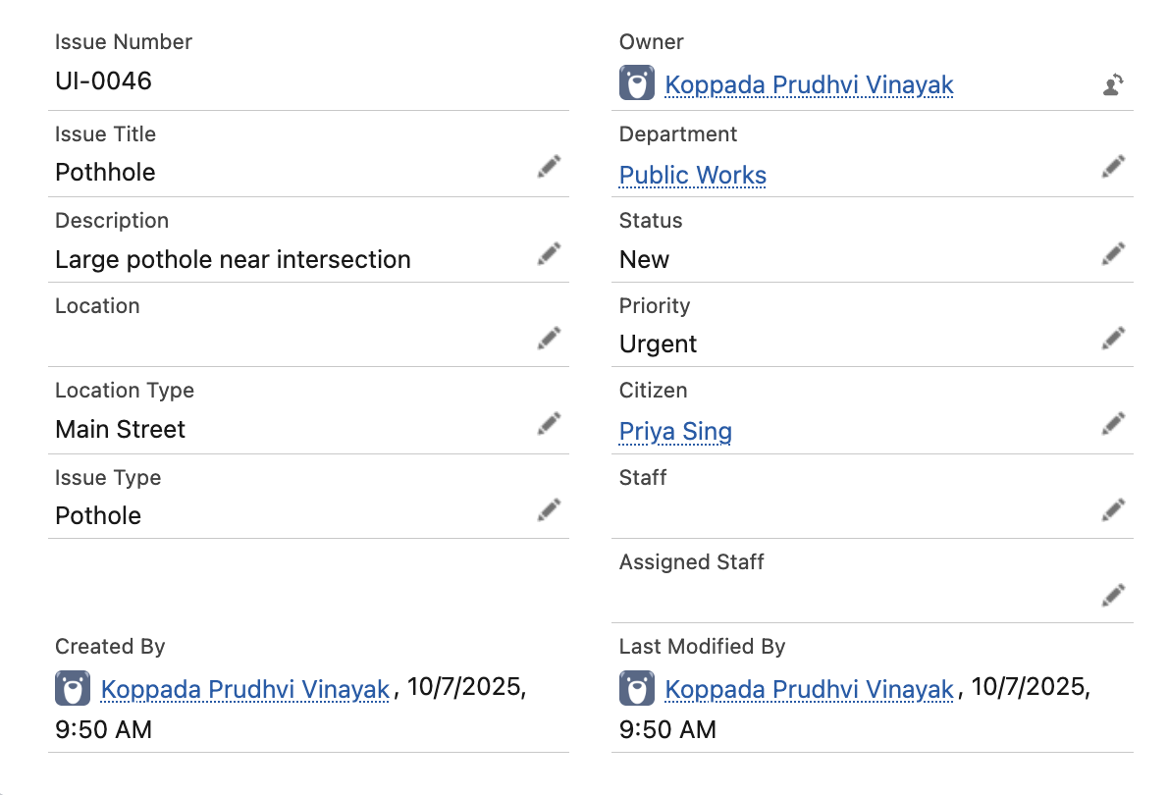

**Use Case / Scenario:**  
Approval Process for Urgent Urban Issue

Test Steps (with Input):

1. Create a new Urban Issue with Priority = “Urgent”.
2. Submit for approval.

Expected Result:

* Supervisor receives approval request email.
* Approval status is “Pending”.
* Upon approval, status updates to “Approved” and assigned staff is notified.

Actual Result:

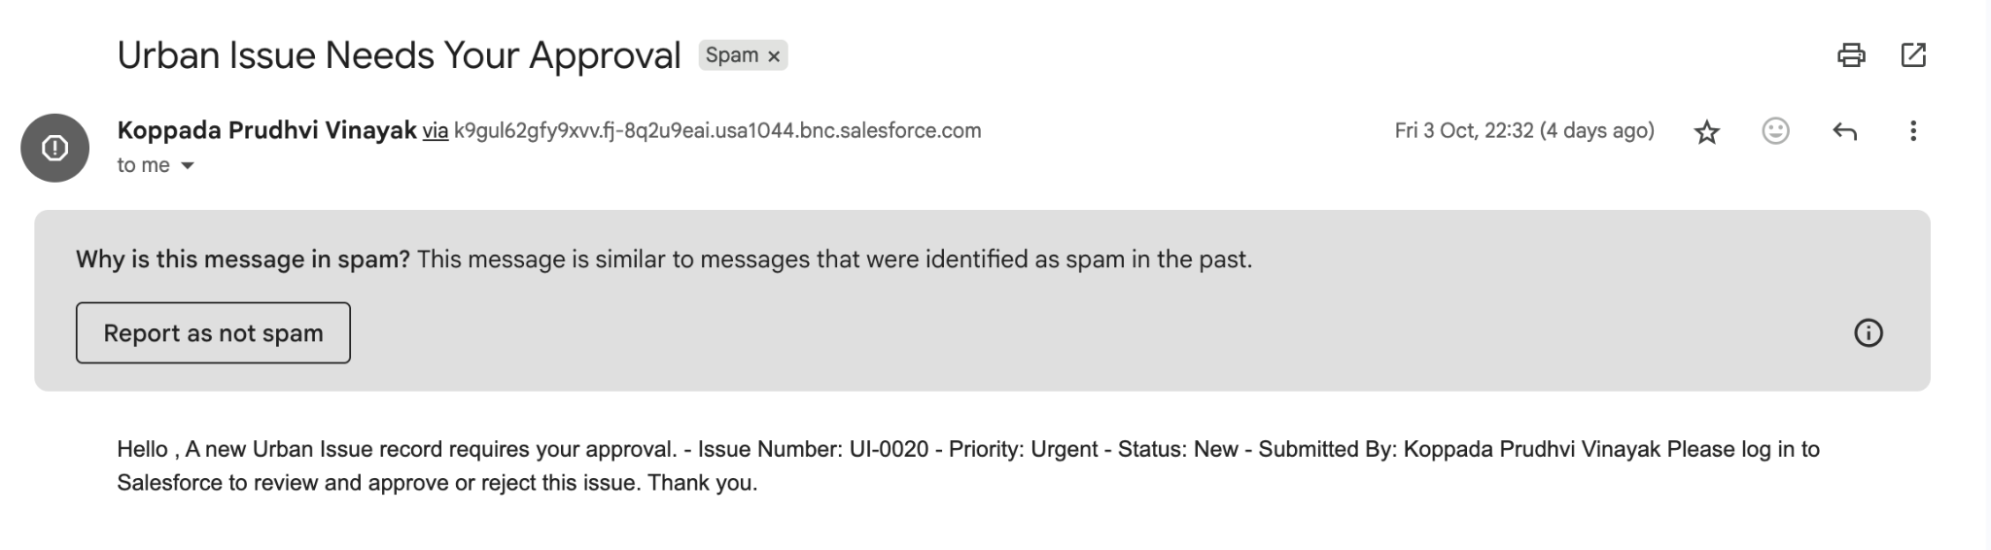

**Use Case / Scenario:**Validation Rule – Government ID Required

Test Steps (with Input):

1. Attempt to create a Citizen record without a Government ID.

Expected Result:

* Error message: “Government ID”.

Actual Result:

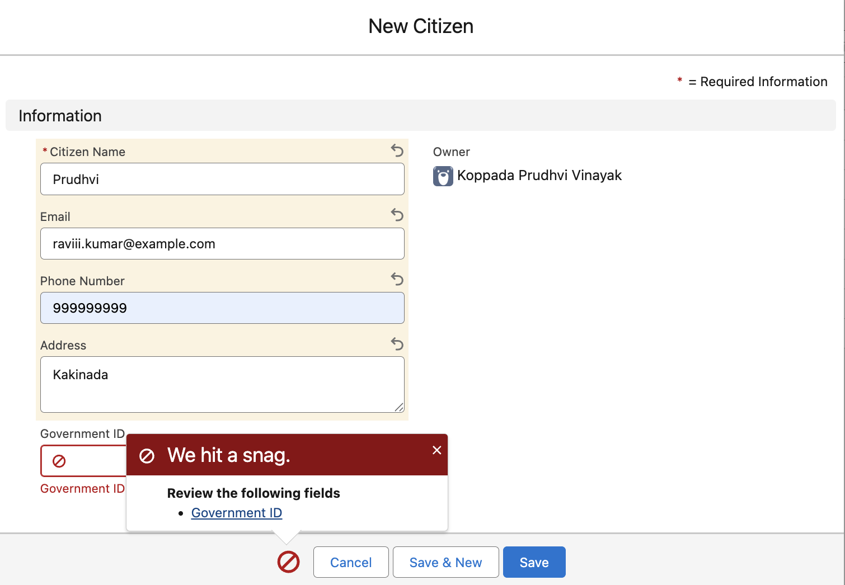

**Use Case / Scenario:**Duplicate Rule – Prevent Duplicate Citizens

Test Steps (with Input):

1. Attempt to create a Citizen with an email that already exists in the system.

Expected Result:

* System blocks creation and displays duplicate warning.

Actual Result:

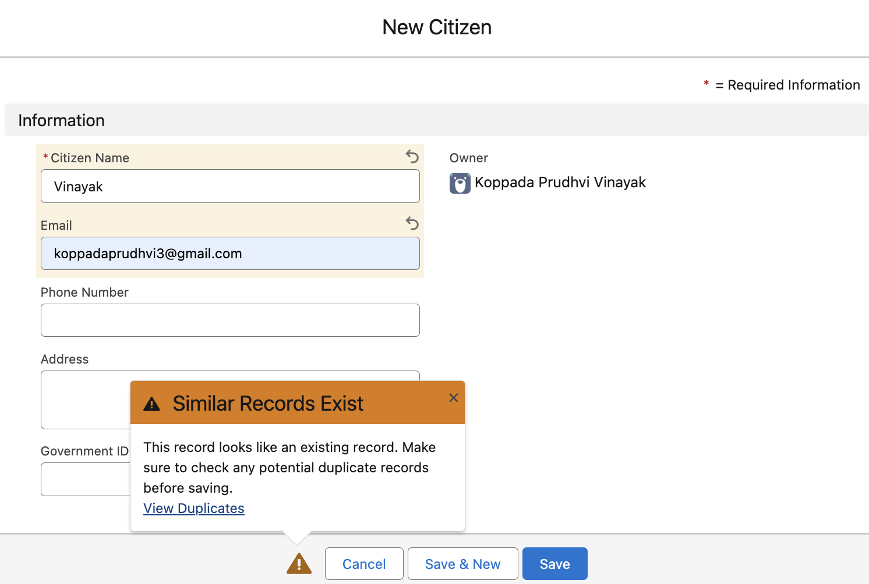

**Use Case / Scenario:**  
When a user creates a new Urban Issue and selects a Department, the system should automatically assign the issue to an available staff member within that department (using round-robin or any configured logic).

Test Steps (with Input):

1. Log in as a user with permission to create Urban Issues (e.g., Department Staff or System Admin).
2. Go to the Urban Issue object and click New.
3. Fill in the required fields:
   * Issue Title: "Streetlight broken"
   * Description: "Streetlight not working at 5th Avenue."
   * Location: "5th Avenue"
   * Department: Select "Utilities" (or any department with at least one staff member assigned)
   * Other fields as required (e.g., Status, Priority)
4. Click Save.

Expected Result:

* The new Urban Issue record is created.
* The Assigned Staff field is automatically populated with a staff member from the selected department (e.g., using round-robin assignment).
* If multiple staff are in that department, the assignment rotates based on the logic.
* The Assigned Staff member receives a notification (if configured).

Actual Result:

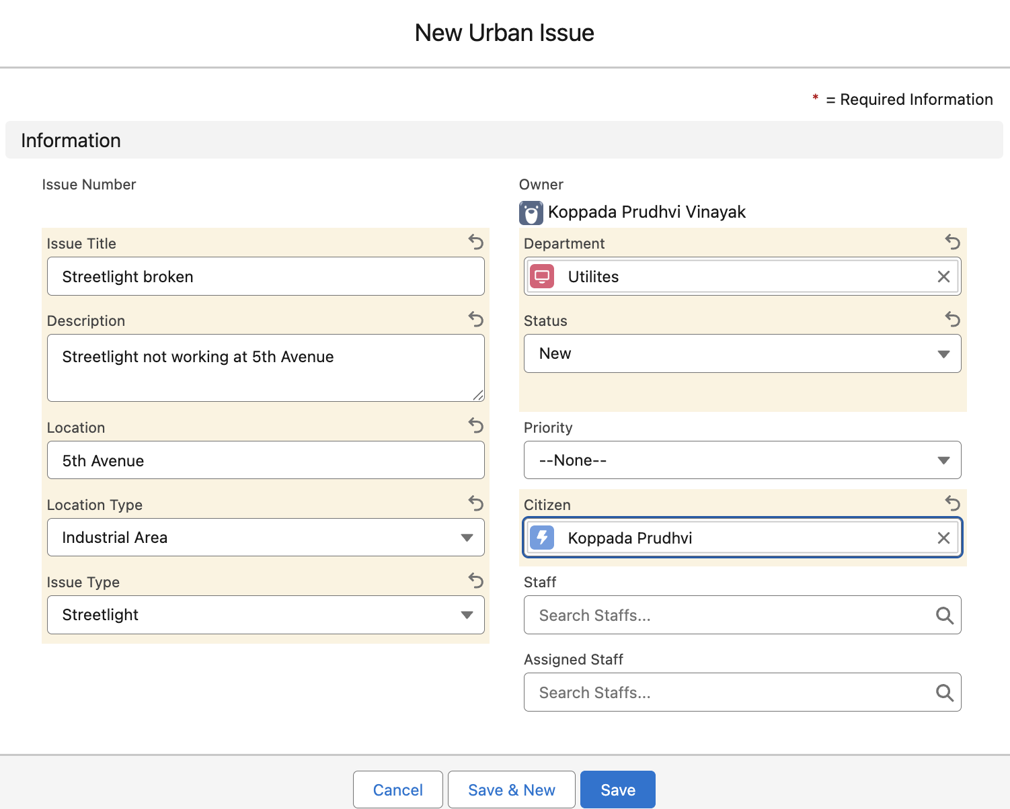

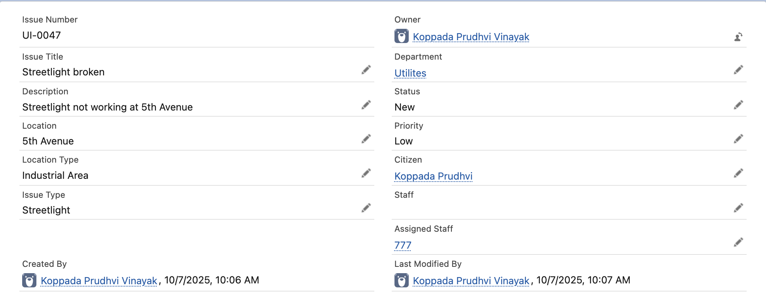

## 

**Use Case / Scenario:**When a user creates a new Urban Issue and selects a specific Location Type, the system should automatically set the Priority field according to predefined business rules (e.g., "Main Road" = Urgent, "Residential Area" = Medium).

Test Steps (with Input):

1. Log in as a user with permission to create Urban Issues (e.g., Department Staff or System Admin).
2. Go to the Urban Issue object and click New.
3. Fill in the required fields:
   * Issue Title: "Garbage not collected"
   * Description: "Garbage has not been collected for 3 days."
   * Location: "Sector 10"
   * Location Type: Select "Main Road" (or another type according to your business rules)
   * Other fields as needed (do NOT set Priority manually)
4. Click Save.

Expected Result:

* The new Urban Issue record is created.
* The Priority field is automatically set based on the selected Location Type (e.g., "Urgent" for "Main Road", "Medium" for "Residential Area", etc.).
* No manual input for Priority is required from the user.

Actual Result:

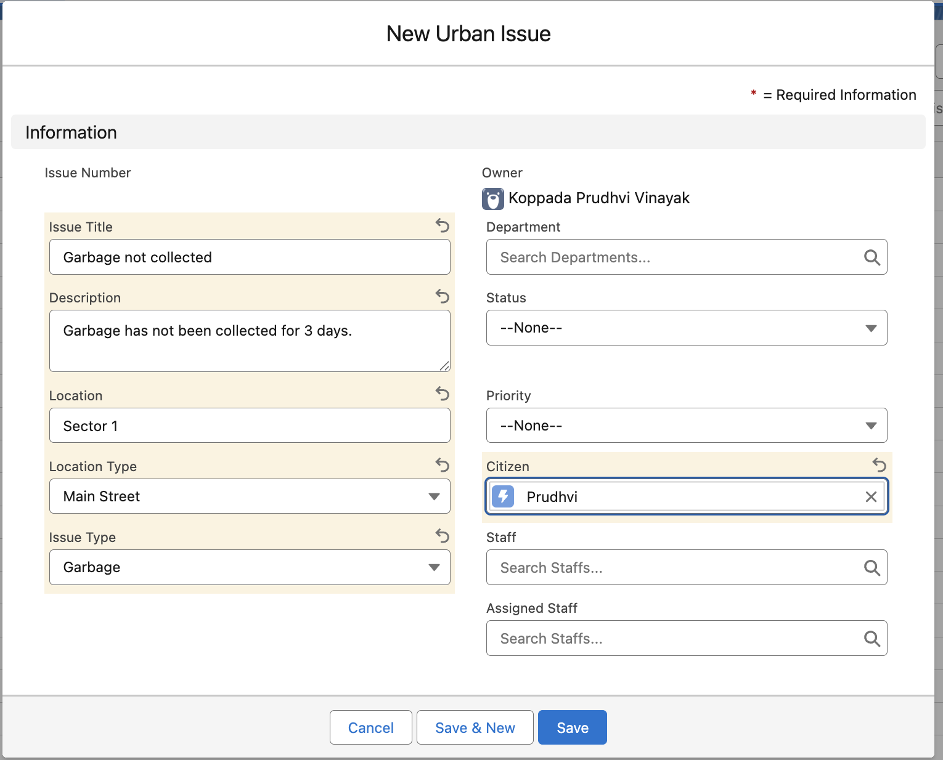

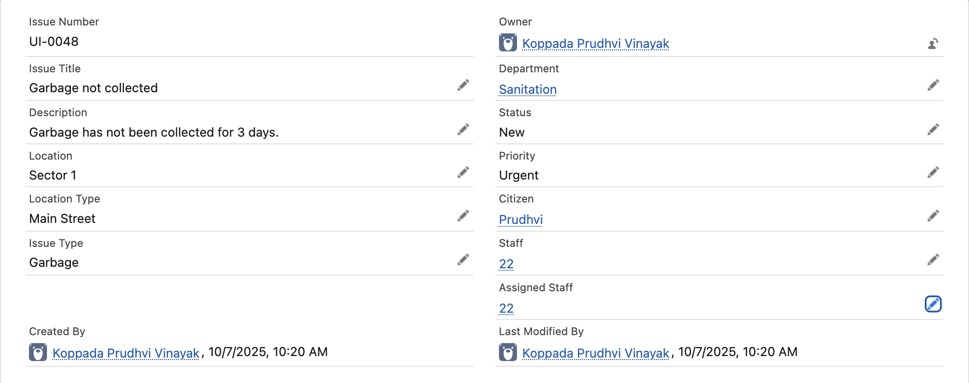

## **Conclusion**

The Urban Issue Management System’s implementation in Salesforce successfully addresses the city’s need for a transparent, efficient, and citizen-focused platform for reporting and tracking urban infrastructure issues. The project’s phased approach ensured robust data modeling, automation, integration, quality assurance, and user-centric design.

Key achievements include:

* Streamlined citizen issue reporting and tracking
* Automated assignment, approval, and notifications reducing manual workload
* Data quality enforced through validation and duplicate rules
* Reliable reporting and dashboards for city management oversight
* Secure, role-based access and compliance with data privacy standards
* Scalable architecture ready for future enhancements (IoT, analytics, etc.)

# **Future Enhancements**

# Chatbot Integration: Add an AI-powered chatbot to help citizens report issues, get instant updates, and answer FAQs, improving user engagement and support.

* AI Suggestions:  
  Use AI/ML (e.g., Salesforce Einstein) to auto-suggest issue priorities, predict escalations, and recommend assignments, making resolution faster and smarter.
* Mobile App:  
  Develop a mobile app with GPS, photo upload, and push notifications for easier field reporting by both citizens and staff.
* IoT & GIS Integration:  
  Connect IoT sensors and mapping (GIS) to auto-detect issues and provide real-time location analytics.
* Community Portal:  
  Enable forums, voting, and transparent feedback for greater citizen participation and trust.
* Advanced Analytics:  
  Add more powerful dashboards, trend analysis, and export options for better city management decisions.
* Multi-language & Accessibility:  
  Support additional languages and accessibility features to serve all citizens.

These enhancements will make the system smarter, more responsive, and ready for future city needs.